Contents

Introduction 1

Conceptualisation 1

Method 4

3D Modelling 4

Textures 13

Scene 17

Arm Model 17

Rigging 21

Animation 25

Final Animation 31

Reflection 31

References 32

External Assets Used 32

## Introduction

In this assignment, I was tasked with creating a video render of my choice, including custom produced 3D models, animations and materials. At first, I thought about making a short film-like animation, as that would likely match all the criteria for this task. However, I decided to create a slightly unique render, which is that of a first-person firearm animation that would be used in a 3D game. I created everything in Blender, apart from some material maps which were made in Substance Designer.

## Conceptualisation

At first I wasn’t sure if this type of render would be sufficient for this module, however after considering it more I realised that although this type of animation lacks the sort of ‘personality’ of a short film, it still displays the use of 3D models, rigs, animations and materials. As a Games Technology student, I’ve always wanted to be able to create assets for games, therefore I decided this was exactly what I wanted to do.

I did not do any research for this project, as I am somewhat familiar with firearms and therefore went straight into the creation process. Before doing this however, I needed a reference to work from. Rather than taking one from online, this time I decided to make my own. I have a model BB airsoft gun at home, and so decided this would be the perfect reference as not only could I take the images myself, but I could inspect it in real life to see every little detail from any angle, and to even use as an animation reference by holding it out in front of me to see how I should position every finger.

First, I started by taking a bunch of reference images from different angles.

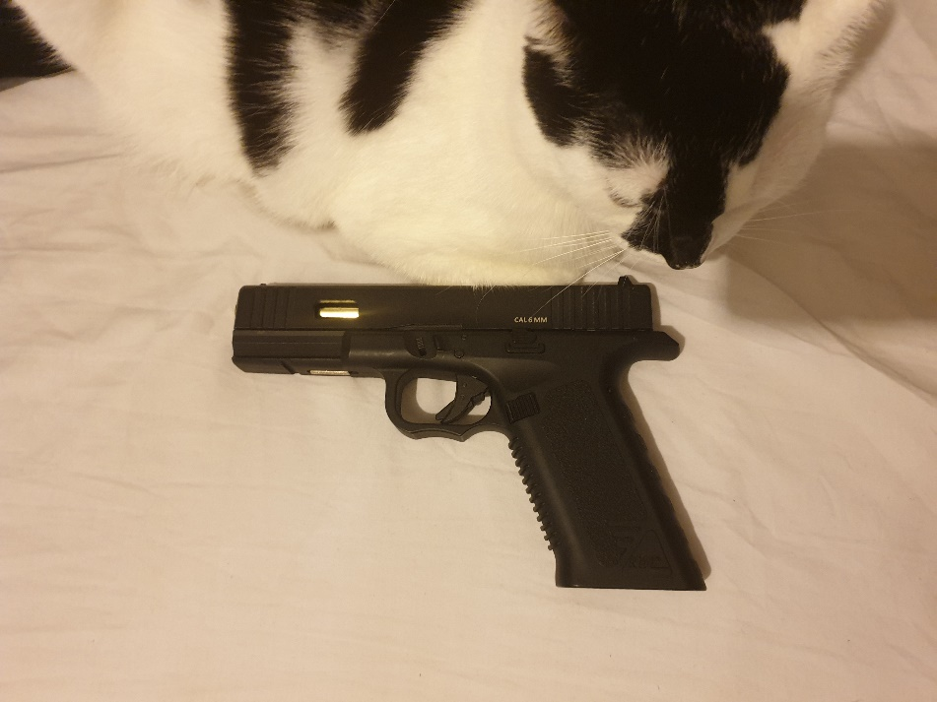

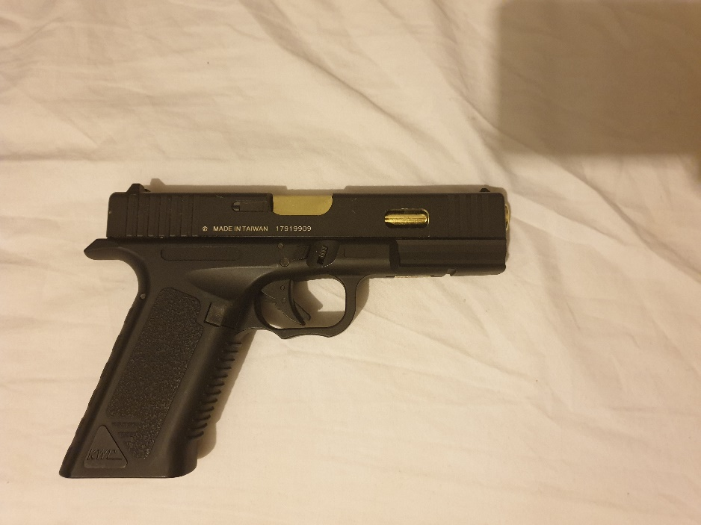

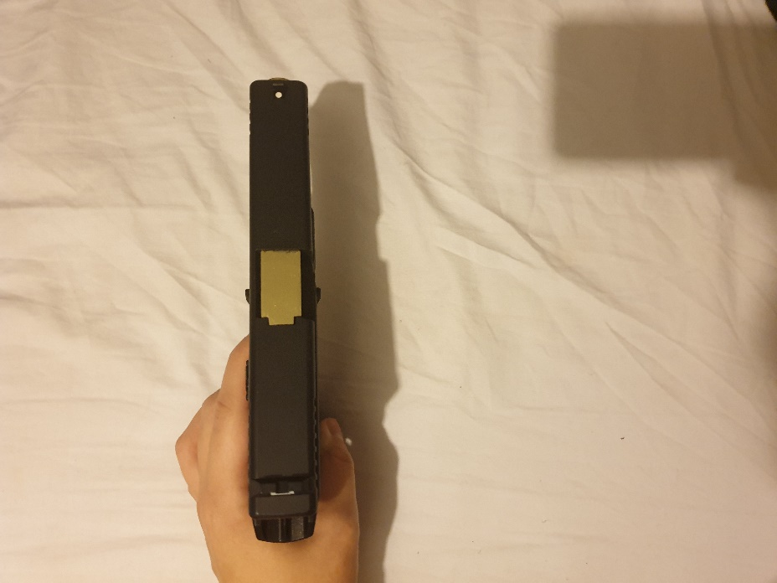

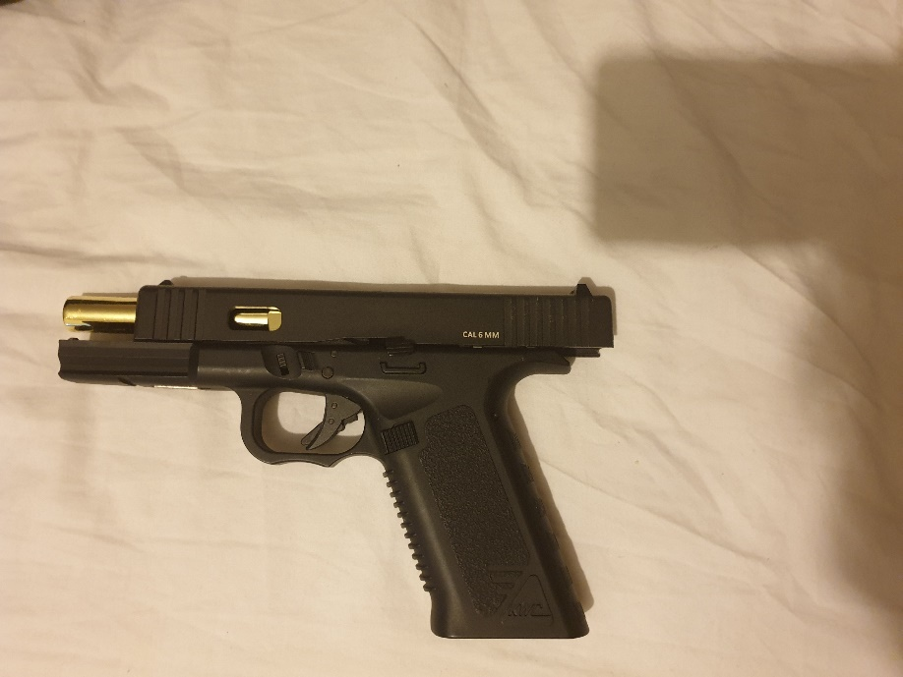

Next, I took one of the side profiles into Photoshop, and traced an outline around each detail I wanted to model before removing the image. With this, I was left with a blueprint image of the pistol which I could use to trace my model around and ensure the scale is correct.

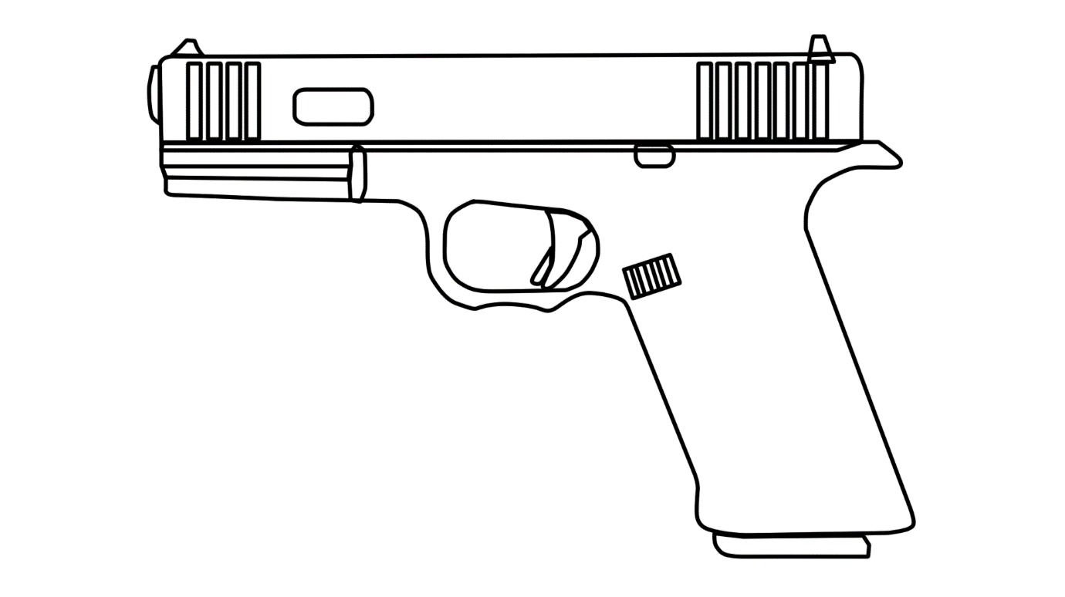

After this, I placed the reference image into Blender and moved straight onto the modelling.

## Method

### 3D Modelling

I begun the modelling process by creating the basic shape of the slide, the top part of the weapon. I decided to split the model into separate parts so that it would be easy to animate each bit later. I extruded the basic cube to fit the reference image, added some loop cuts to every corner and redid the edges to make them more sloped.

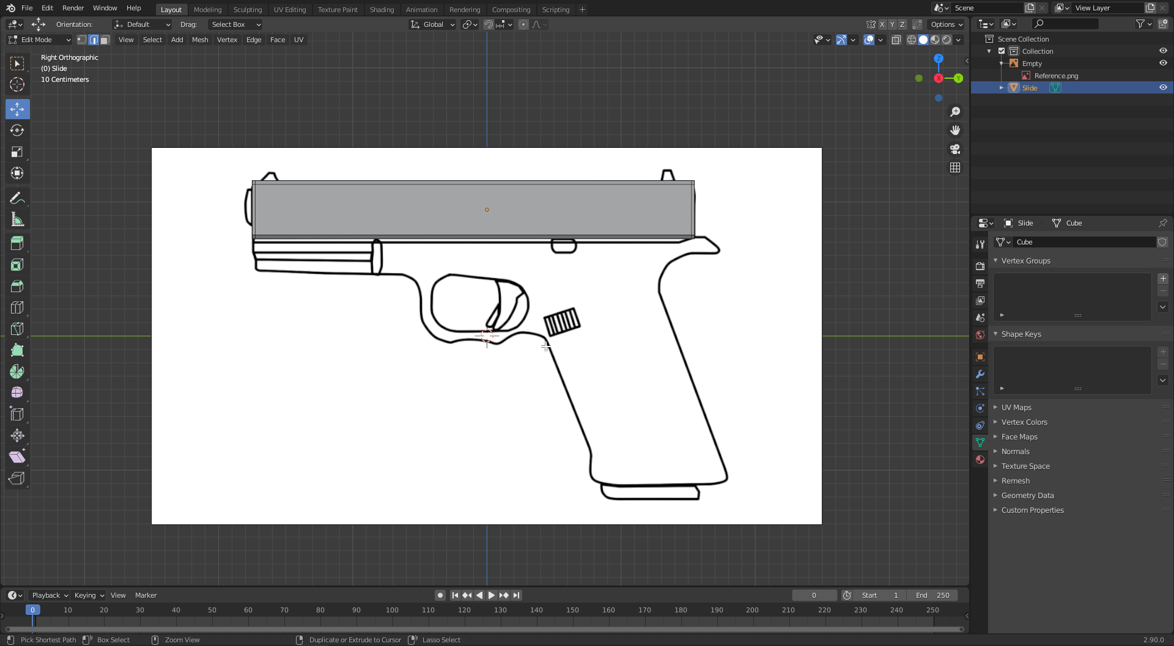

Next, I created a new object, and began extruding out a very simple version of the weapon’s body. This is so that I could then more subdivide and loop-cut every part that requires more detail.

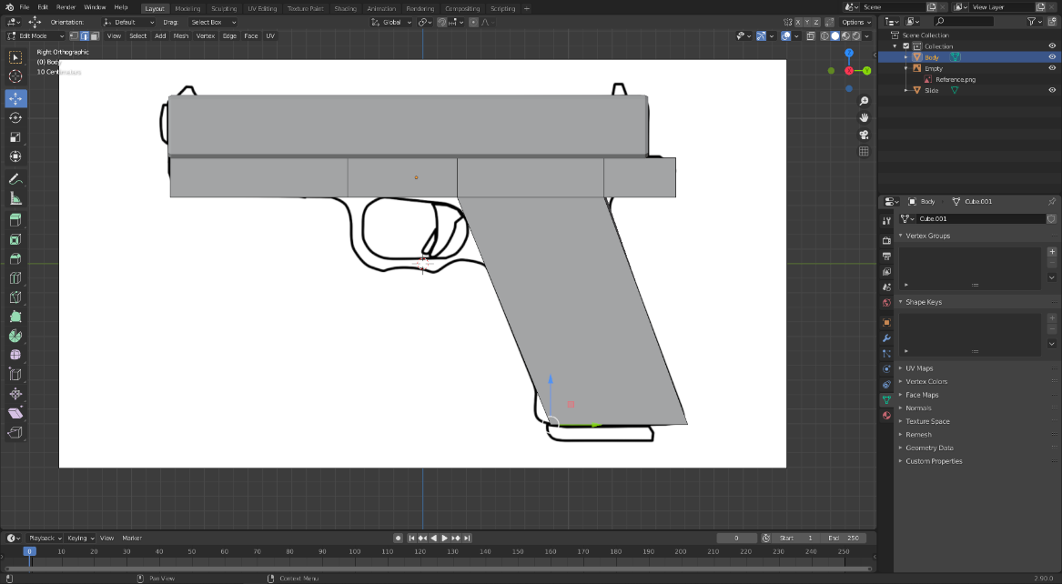

After having the basic shape done, I created several loop-cuts on the grip and began shaping it in more detail. I took careful consideration into making sure I am only working with quads and going back over my mistakes later such as the one in the upper right. There may have been a few that I missed, however I spent a lot of time going back and redoing entire faces to make sure they are all quads.

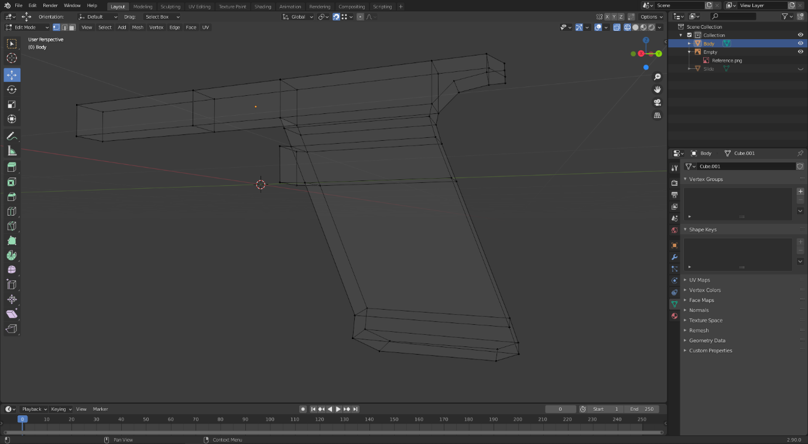

After shaping out the trigger guard, I extruded the entire body outwards and scaled it down to get a more rounded out and three-dimensional appearance, as the top part of the body is typically thicker than the grip.

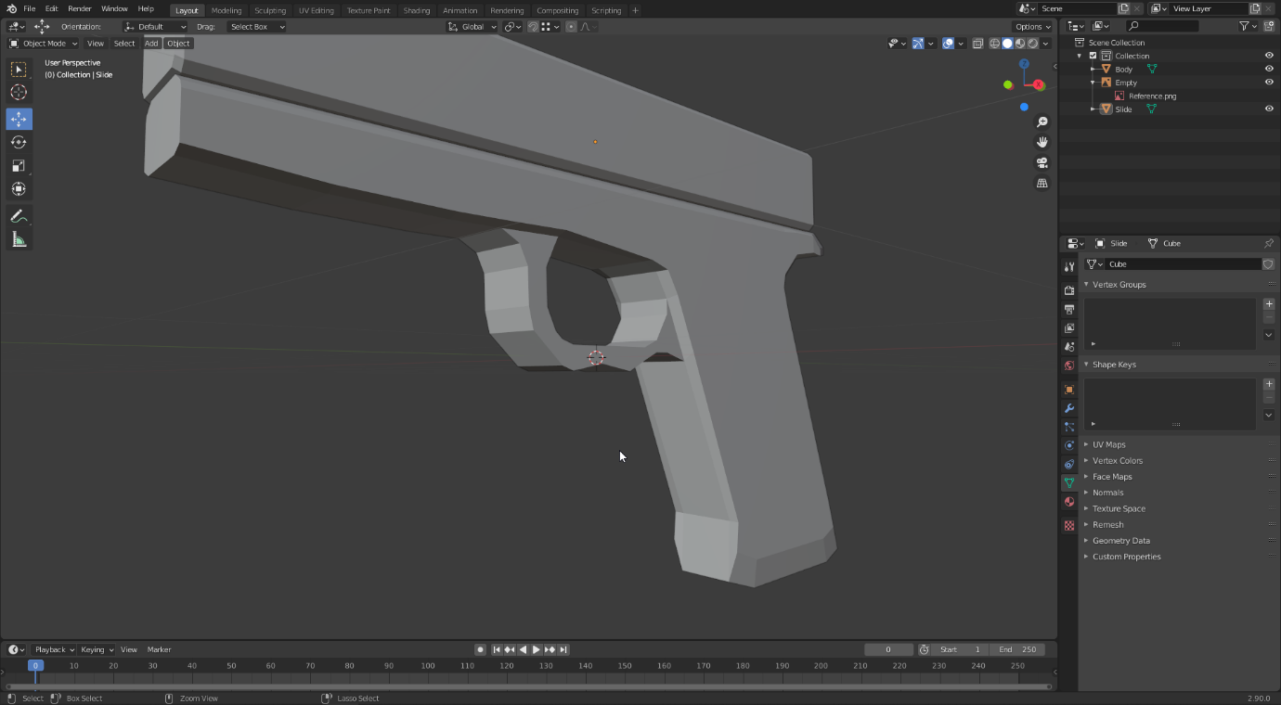

Next, I moved onto the finer details, such as the front of the body which curves inwards heavily. To achieve this effect, I subdivided the edges I left at the front, and then positioned them inwards at varying distances.

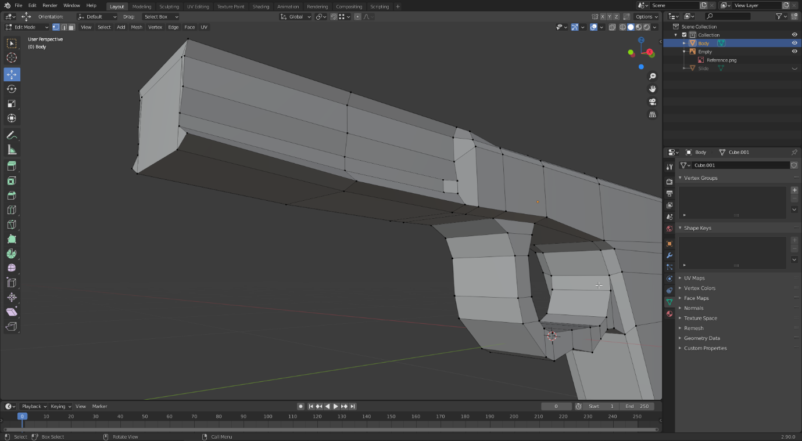

I did the same for the back part, checking against the reference image to make sure the scale is correct. For the inward grooves, I subdivided several times and then deleted the face before extruding the edges inwards and reconnecting the faces.

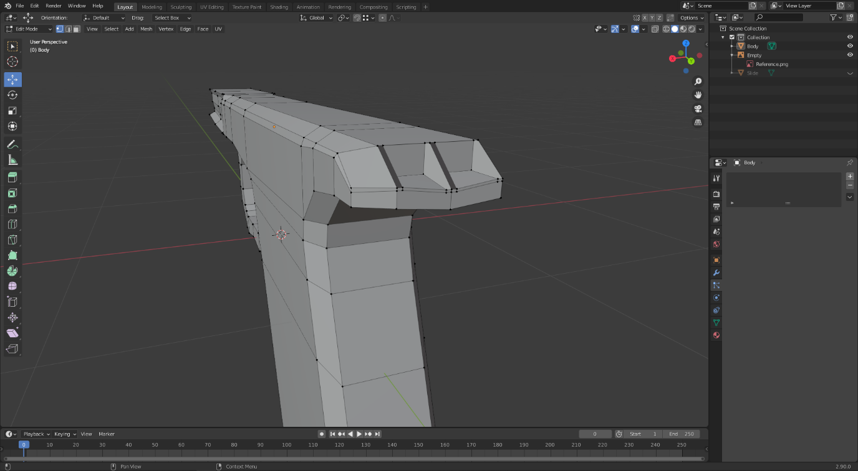

With the body done, I moved onto modelling the slide. I started with creating a hole going straight through the front, which I did by adding several loop cuts and then deleting the face. To fill the insides, I extruded every vertex of the hole inwards, then extruded again but this time scaling outwards and finally connecting both sides together. This gives the weapon a more solid feeling when looked inside of, but there is only a small area inside. Furthermore, I modelled the front part of the slide, which extends downwards into the body.

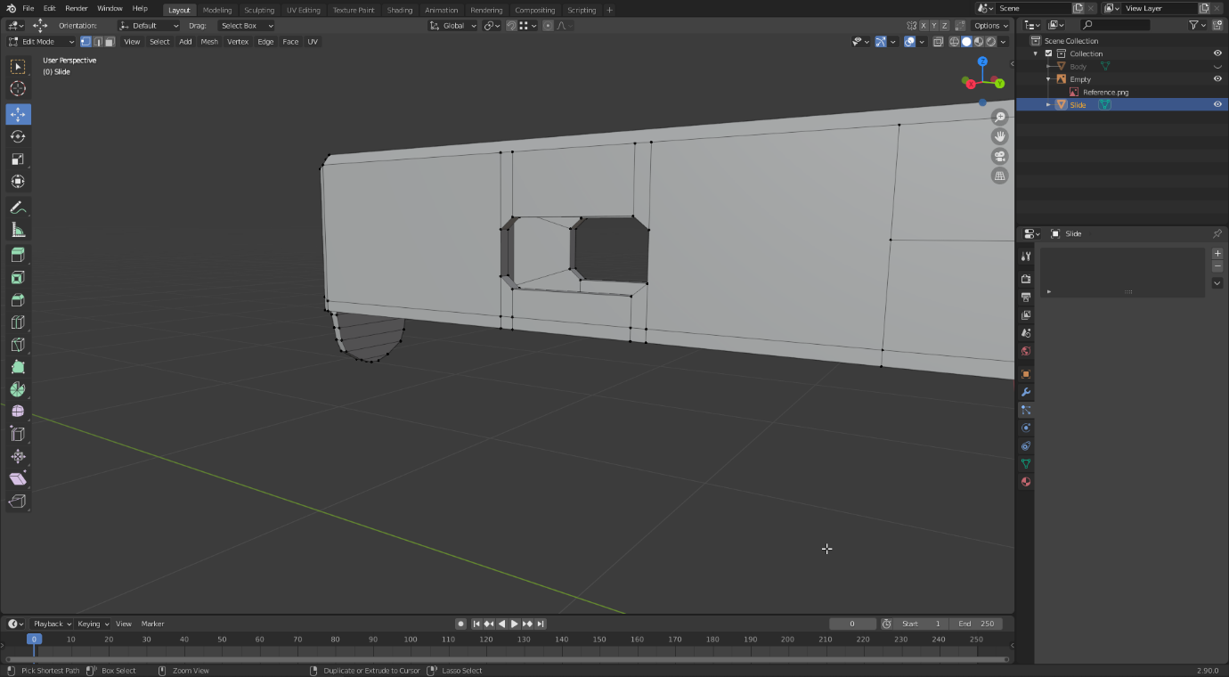

I continued adding more detail in the same way.

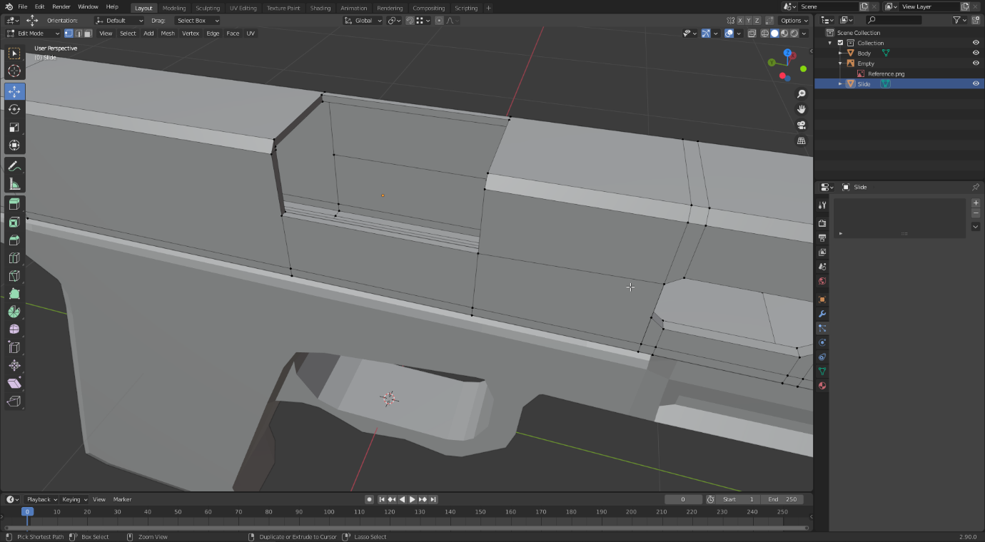

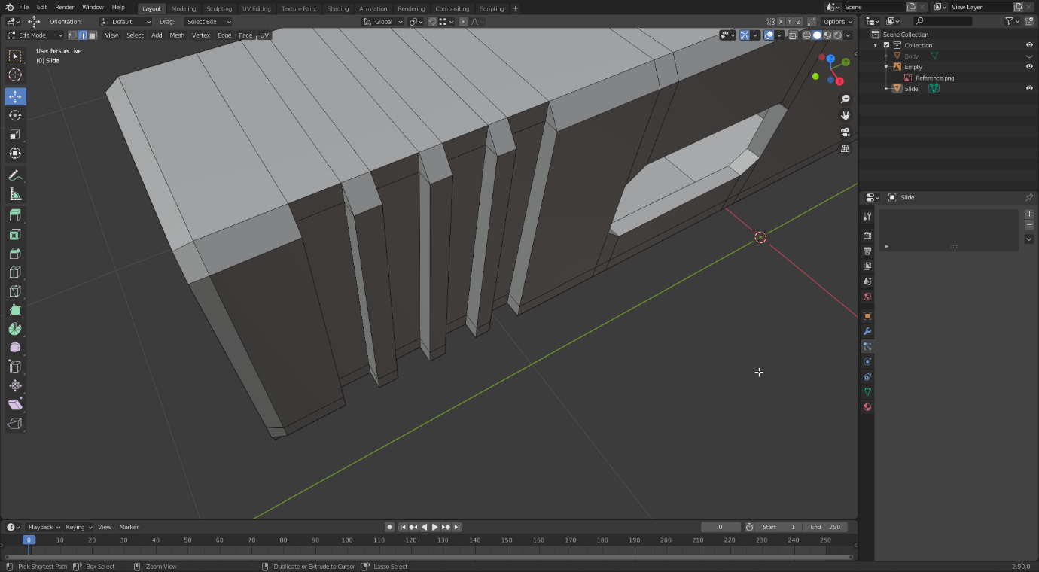

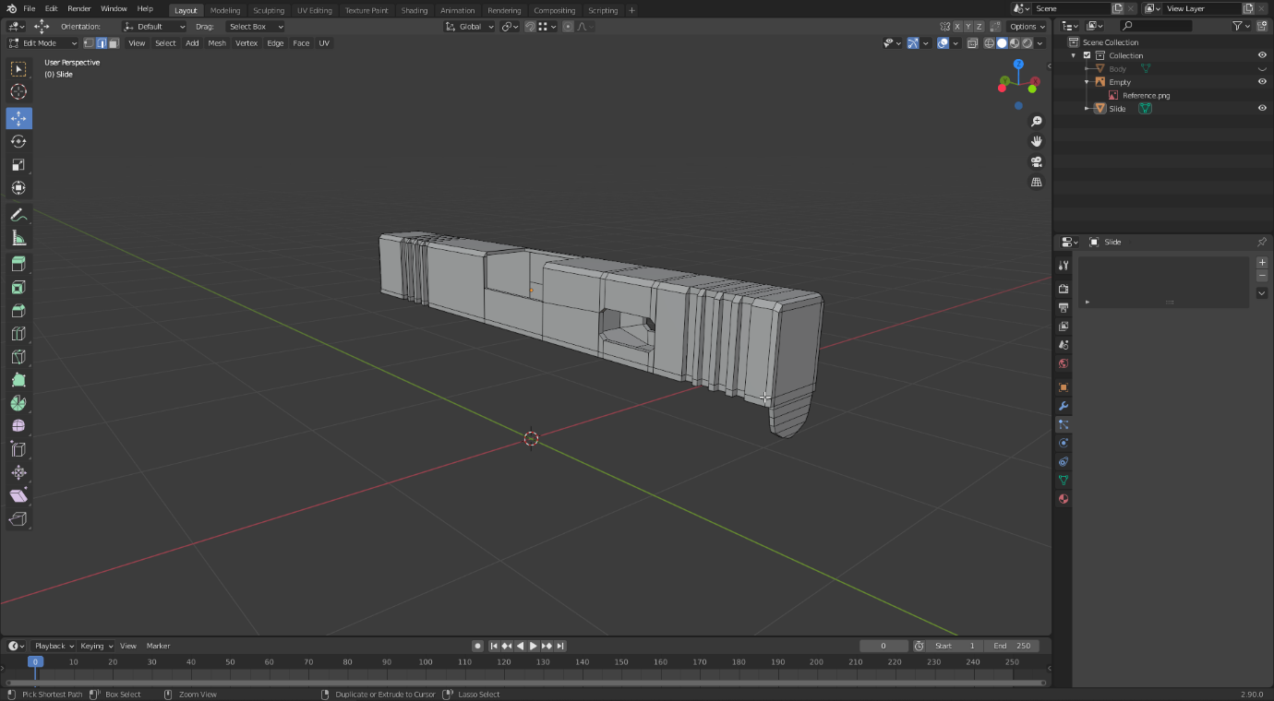

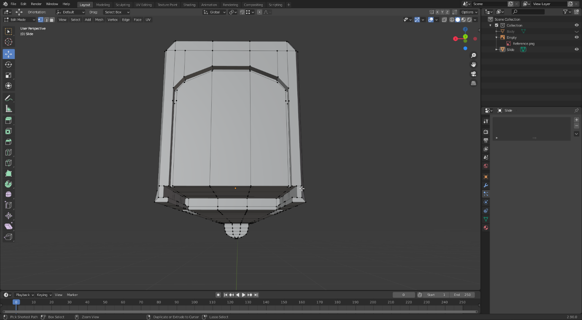

For the other details such as the trigger and cylinder, I created completely separate objects and modelled them the same way. Some of them could have been a part of the same object, such as the cylinder being a part of the body as it never moves away from it.

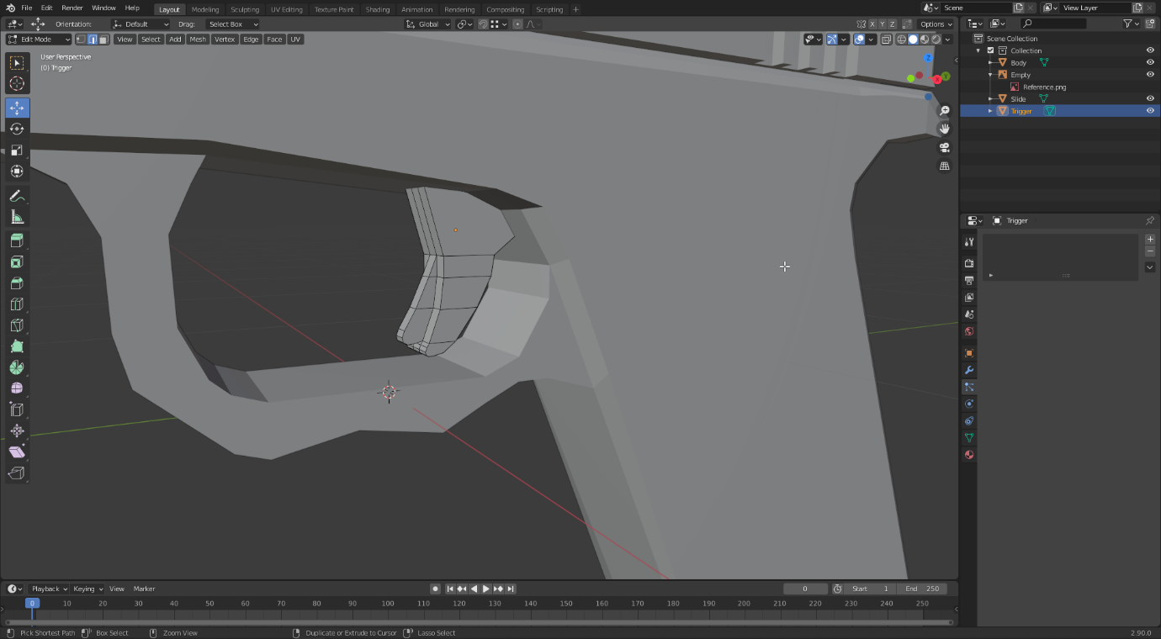

I considered making the inside of the barrel hollow, however, I tried to get into the mindset that this could have actually been a video game asset, in which case I would want to not include useless faces that would cost processing power. Therefore, I decided to leave the front of the barrel filled in as in the animation the player never looks down the barrel.

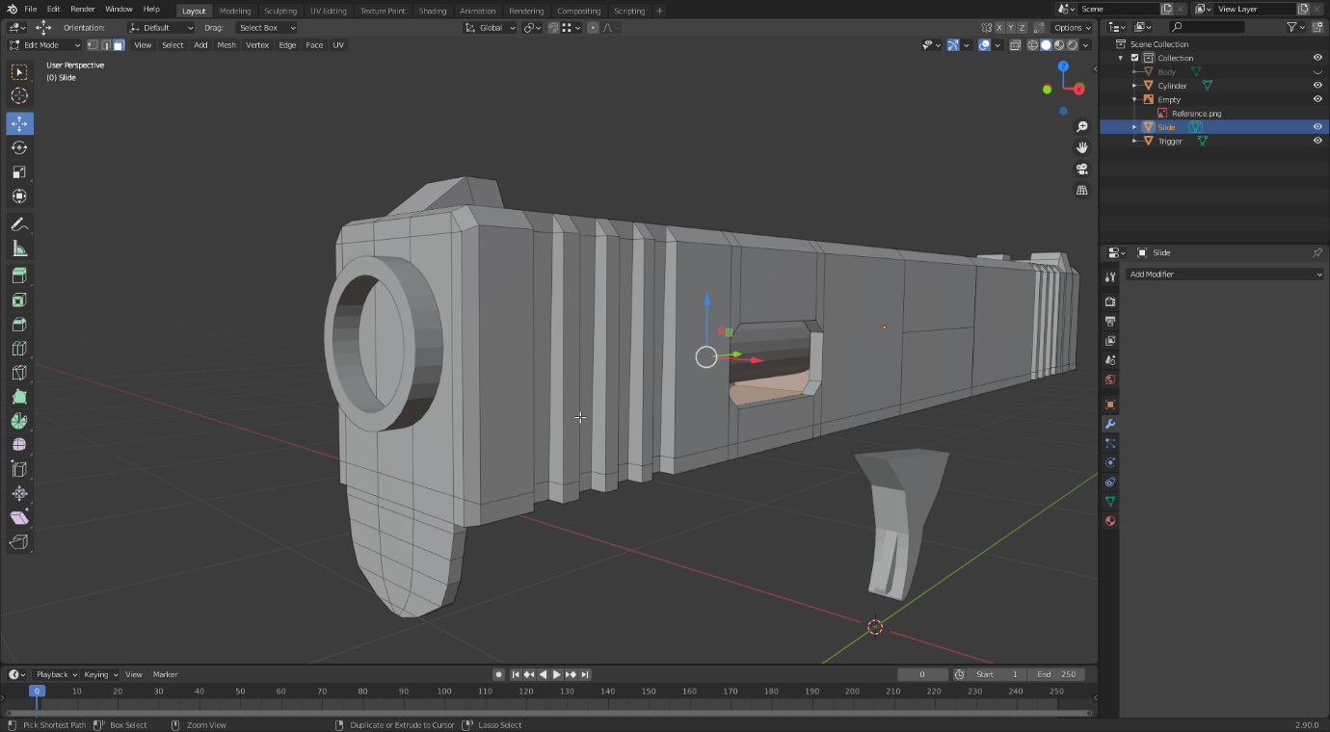

I also considered using the Boolean modifier for parts where slide protrudes into the body, however this did not yield the results I wanted, so I simply made a series of loop cuts and moved the vertices on the body around the shape of the slide.

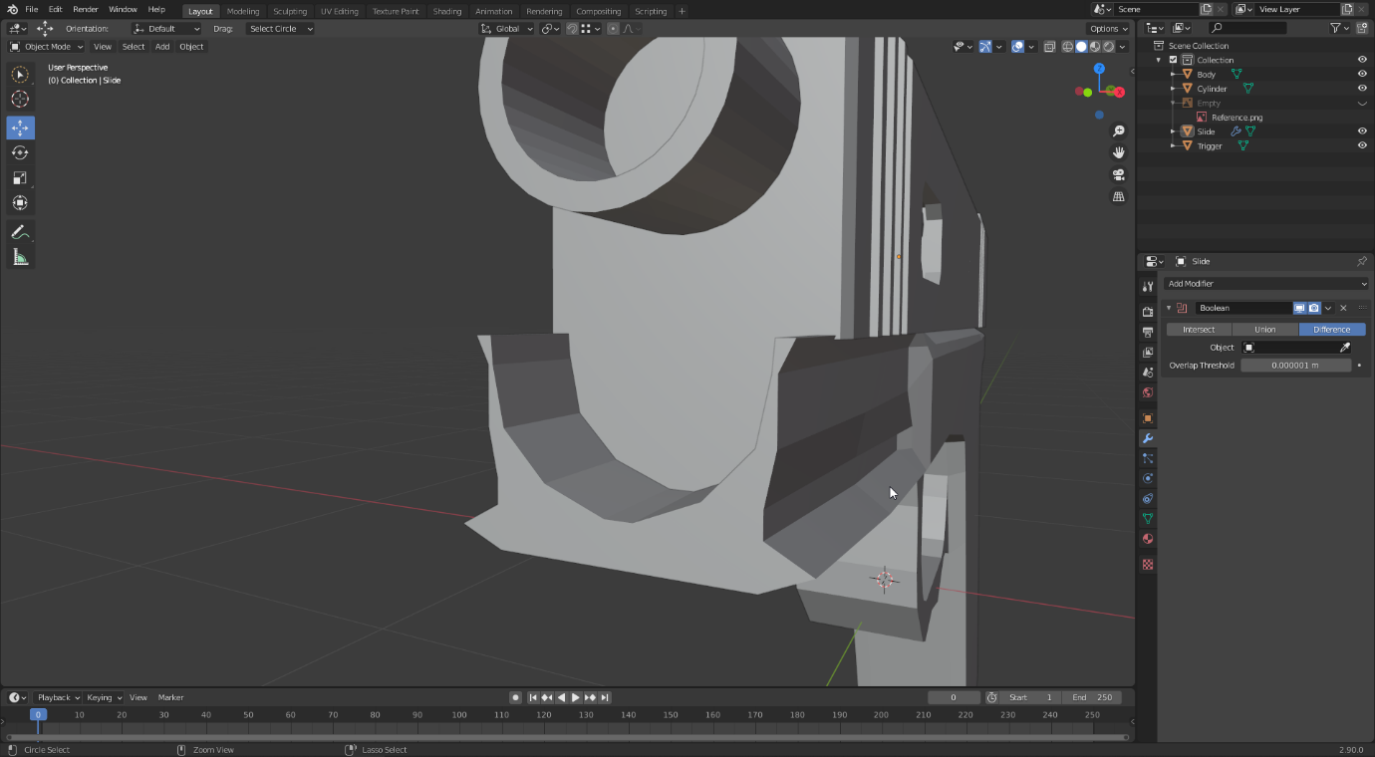

I wanted to be able to aim down the sights, so I had to make sure they aligned perfectly. To do this, I made subdivisions for the front and back sights, and aligned them identically on the x-axis, split into three across the top of the slide. This allowed me to simple extrude them upwards, with the middle part of the back sight being half the size of the middle part on the front sight. This aligned them perfectly when viewed from the back.

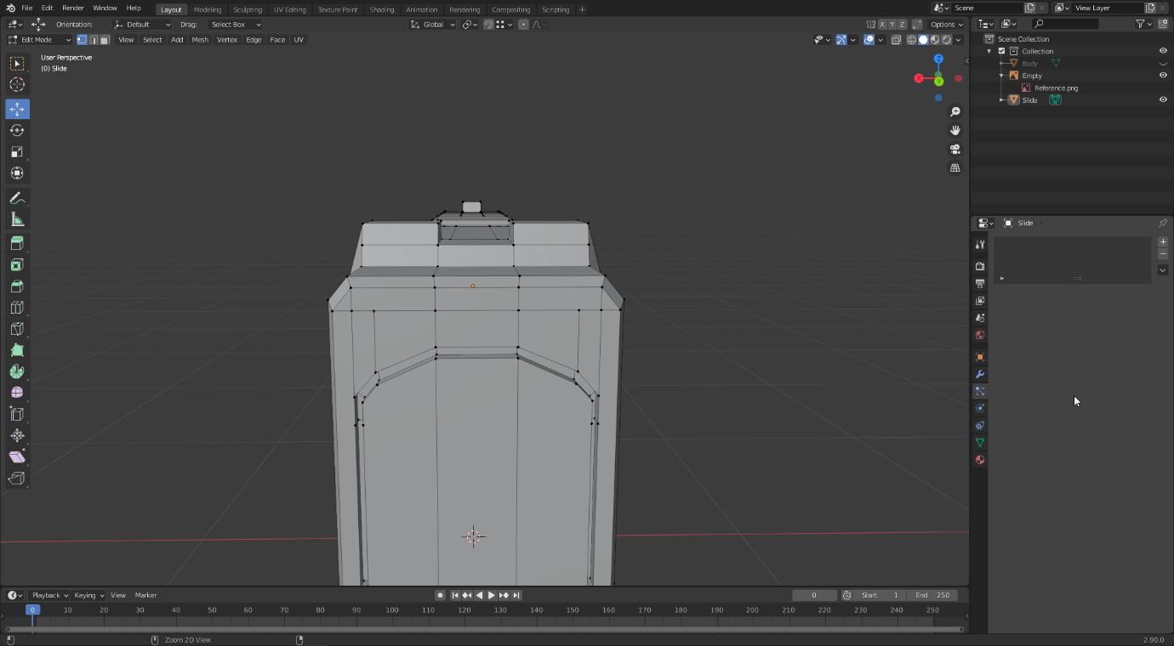

For the magazine, I begun by cutting the face at the bottom of the grip and extruding upwards from the hole that was created. I also cut the bottom part of the slide that goes into place it is pulled backwards, which means if a detailed animation was made using the inside of this model, the magazine, slide and chamber would align together. This was not necessary for my animation, but the option to do so was available. As for the magazine itself, I selected the faces on the inside of the grip, duplicated them and then split them into their own object to get the exact same shape that fits perfectly on the inside. From this, I added extra detail to make it appear more like an actual magazine.

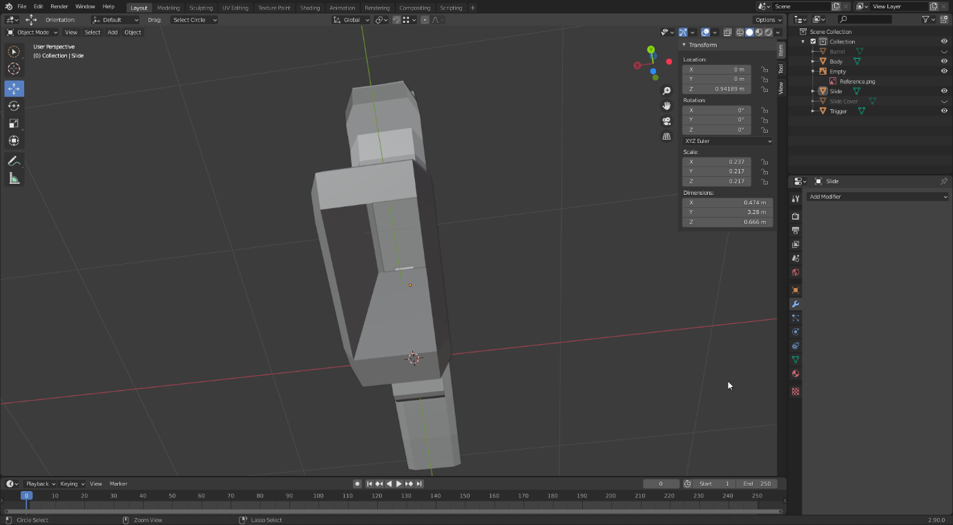

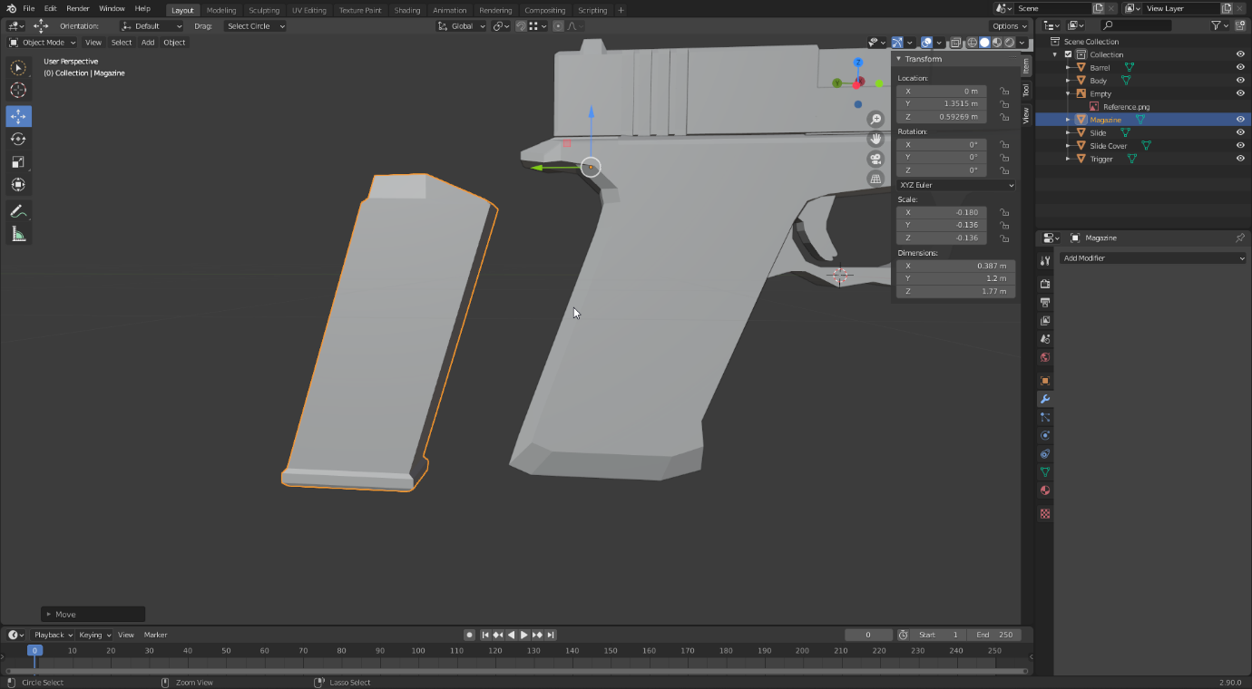

With that final detail, the 3D model was fully complete.

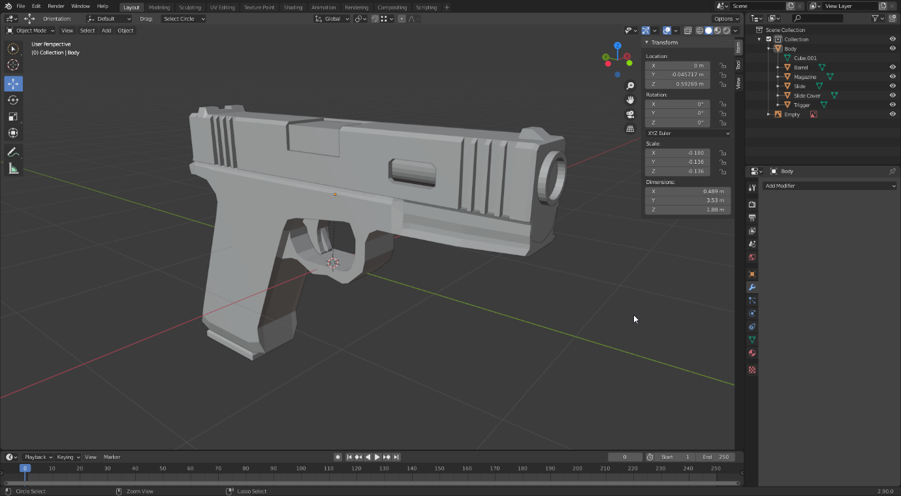

### Textures

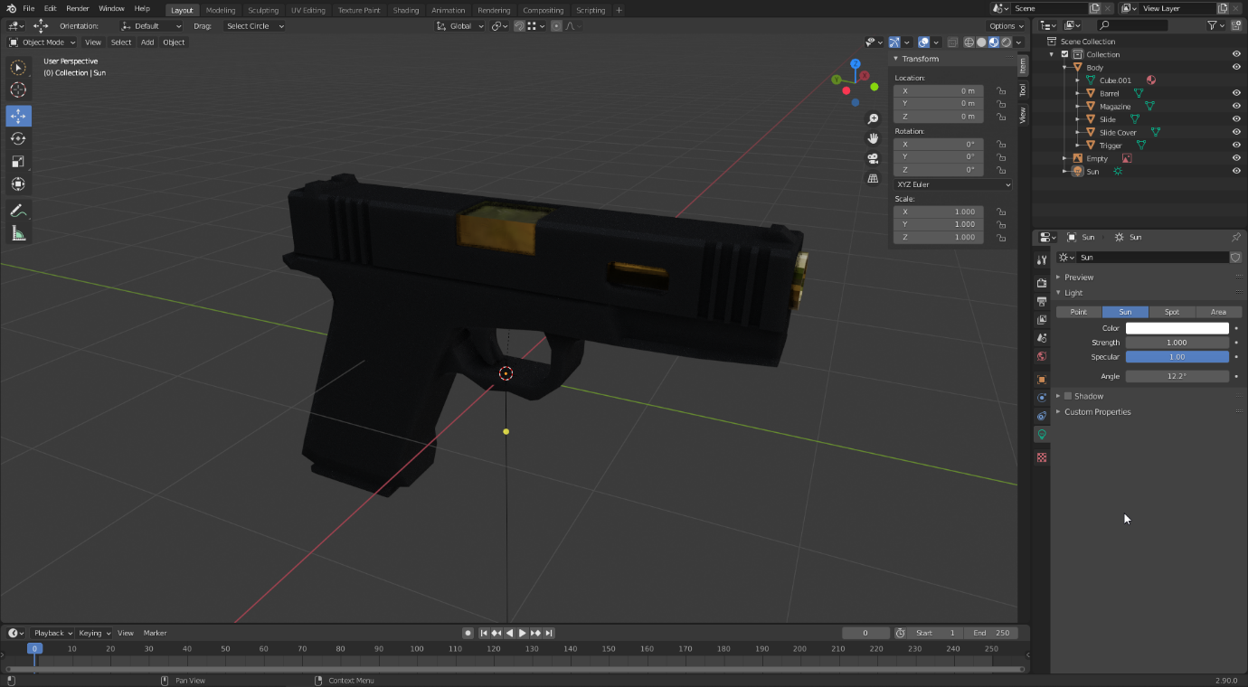

At first, I used a mix of Blender materials and a PBR metal material made from Substance Designer. These can be seen on both the weapon and the hands from now on. However, towards the end I decided I wasn’t happy with these textures and decided to turn them all into PBR materials in Substance Designer. Therefore, I will go through these materials now, even though they may not appear in the pictures until the end.

I made three materials in Substance Designer; gold, polymer and cloth. However, cloth was just a very slight variation of polymer, so I will only cover the creation of gold and polymer. The environment materials were done directly in Blender.

For the gold material, I wanted a brushed finish with slight imperfections in the form of scratches. To achieve this, I combined anisotropic noise with BnW spots, which is also a noise map. I blurred the spots to make them less grainy and put the result of the blend into a normal map to get a bumpy finish.

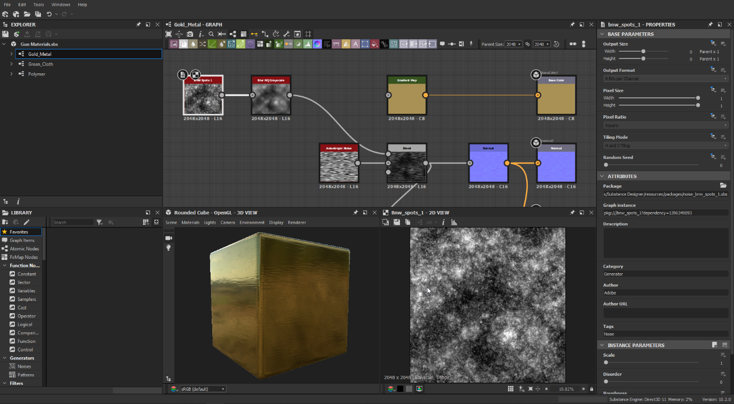

For the roughness map and ambient occlusion map, I blended that noise with a grey uniform colour, and then blended it again with scratches. To make these scratches, I used a scratches generator, which I blurred to make the scratches look less defined, and then adjusted the levels to make them brighter. The output was used for the roughness map, and into a HBAO node which went into the ambient occlusion. Finally, for the height map, I simply used a normal map to height map coversion.

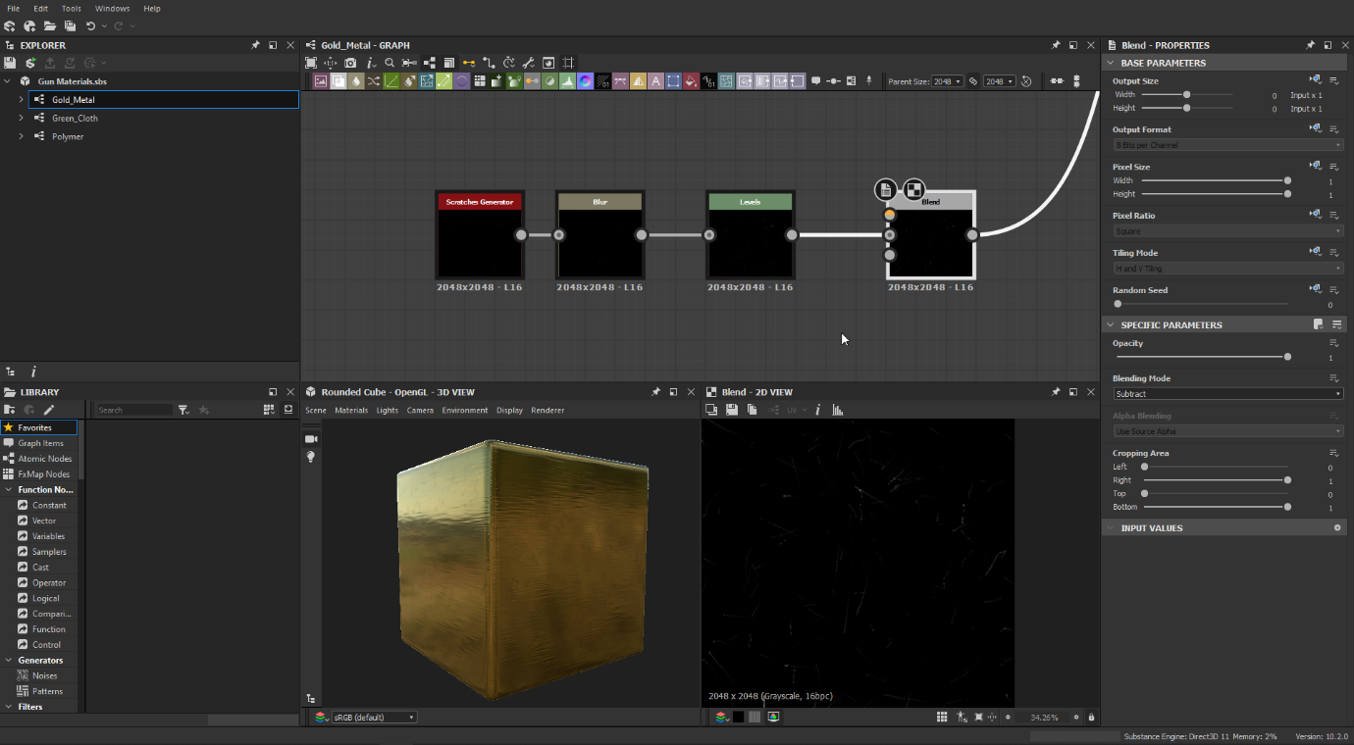

For the weapon, I wanted to make a polymer-like material, which appears smooth but up close has a very heavily bumpy surface. To achieve this, I combined a blurred BnW spots node with another BnW spots, but with the scale set to 8 in order to get a very high number of spots. Together, this created a very bumpy texture which I used for the normal and heightmap.

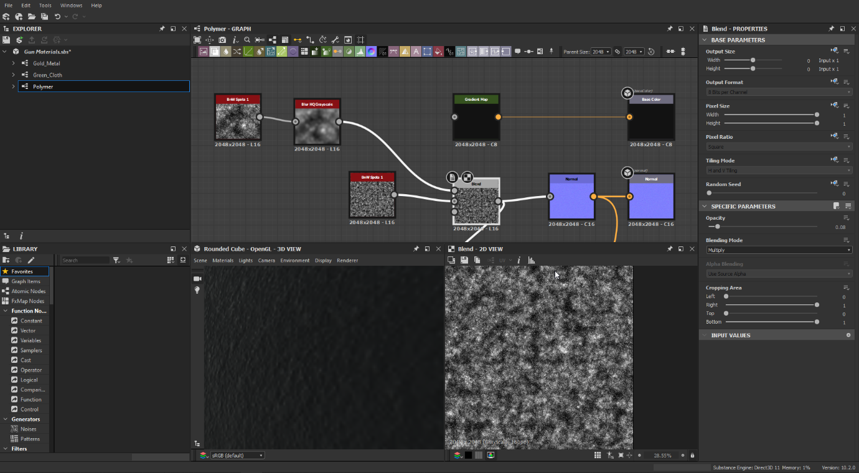

For the roughness map, I used a uniform deep dark grey, blended with the spots to get the same bumpy texture however on a grey slate. I used this for the ambient occlusion, and then inverted the colours to use for the roughness map. From far, this material appears quite solid, however up close it is very easy to see how bumpy and rough it is.

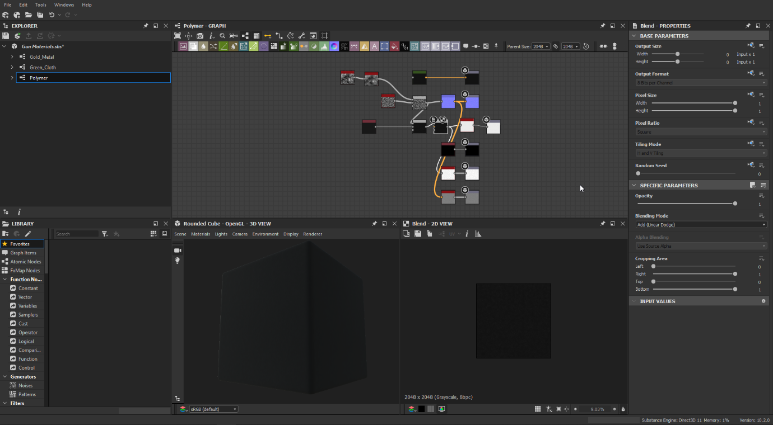

For the cement, I wanted to try to generate a texture within Blender. To do this, I took a Voronoi texture, put through a gamma node to reduce the noise. I used this directly as the displacement map, and slotted it into a diffuse BSDF node which mixed with a combination of a glossy BSDF and diffuse BSDF. I used a higher amount of the Diffuse BSDF, as cement tends to not be glossy however should have a certain amount to appear realistic. I finally used this as the surface output for the material.

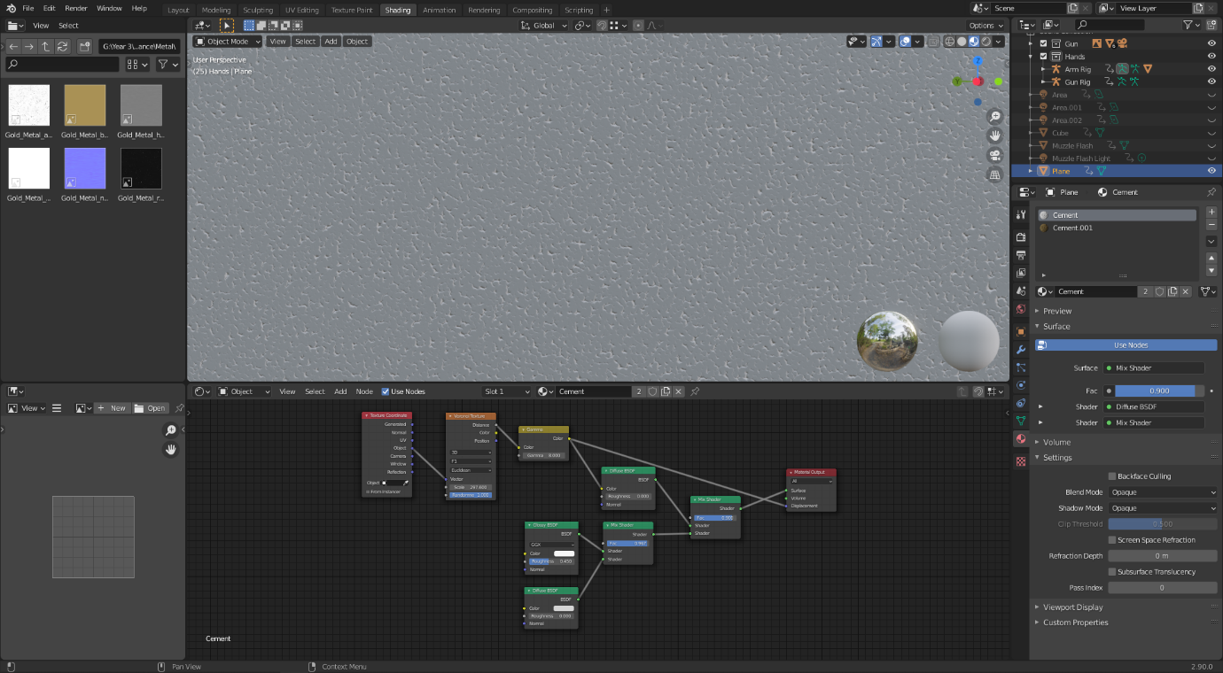

For the polymer and gold, I used a principled BSDF, taking in the different maps as input. The normal map is put through an RGB curves node just to ensure it is read correctly by Blender, and then combined through a bump map with the height map to be used directly in the normals slot. The ambient occlusion and base colour nodes are multiplied, and then input into the base colour. Meanwhile, the roughness and metallic are slotted straight into their respective slots. This ensure they function as PBR materials.

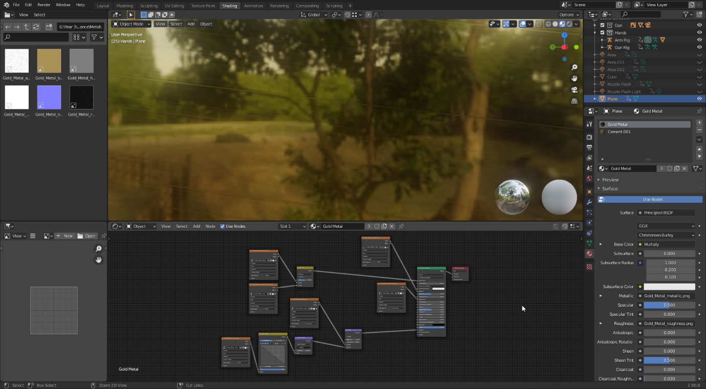

### Scene

Creating the scene was a simple case of extruding a long plane and shaping the top edge to create a slope at the end, before extruding the sides upwards and joining them with a face. To create the target, I subdivided a cube and extruded the sides to make the silhouette of a person and added a stand. This was my most disappointing part of this project, as I wish I put more thought into making a nice environment, and possibly even navigated the character around it. However, video game animation previews are normally shown in a blank space, and I thought having a shooting range would be a better alternative than having nothing. I would say the effort I didn’t have to put into the environment building went into making the main focus of the video, the weapon model and animation a lot more detailed.

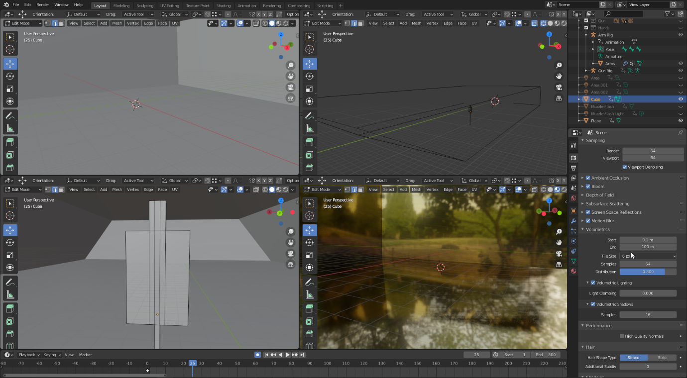

### Arm Model

Before animating the weapon, I first needed a set of hands. This is something I had never done before, so I decided to go for a somewhat low-polygon style. First, I subdivided a cube, and altered the heights of each cut to create an arch for the palm shape.

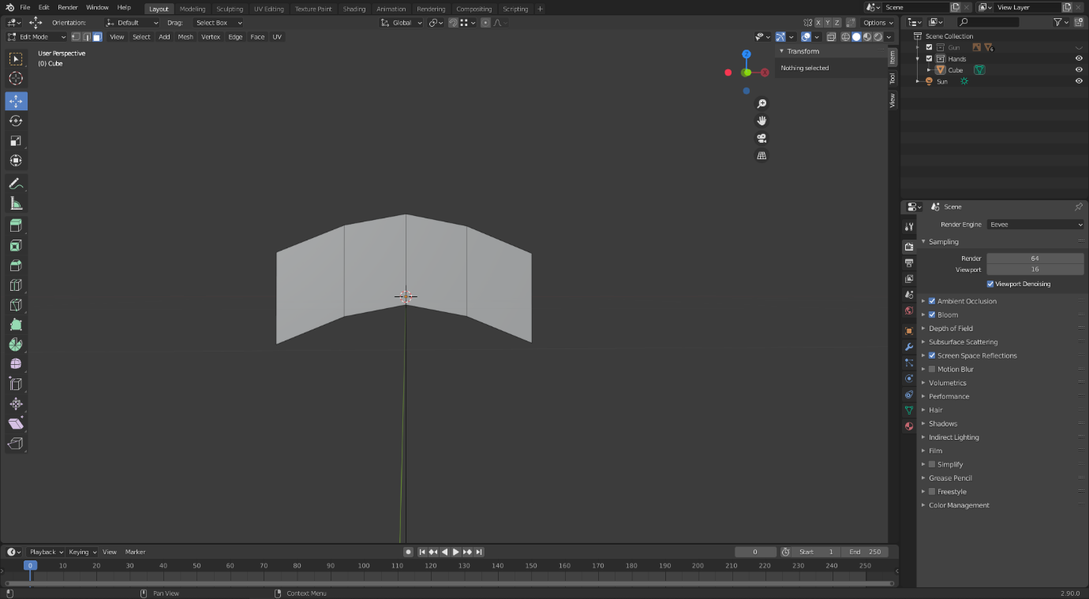

Next, I duplicated the faces at the end, and extruded from them to start creating the fingers. I manually scaled and positioned each face to resemble a hand stretching outwards, getting smaller as it gets further away.

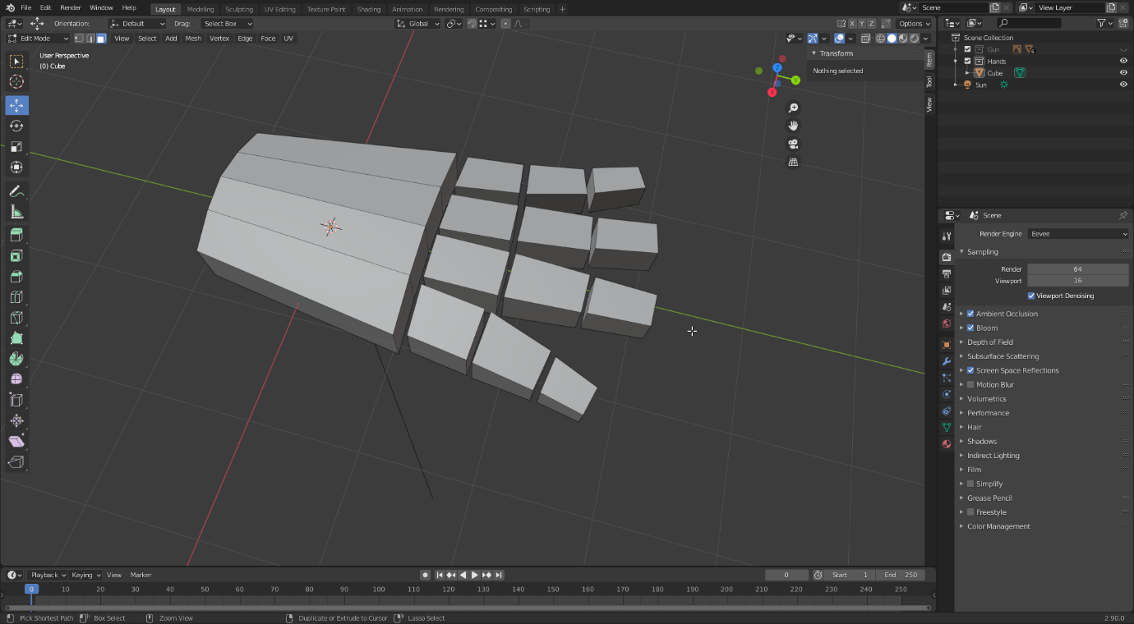

I used the same method to create a thumb, which goes from the back of the palm to the middle and outwards.

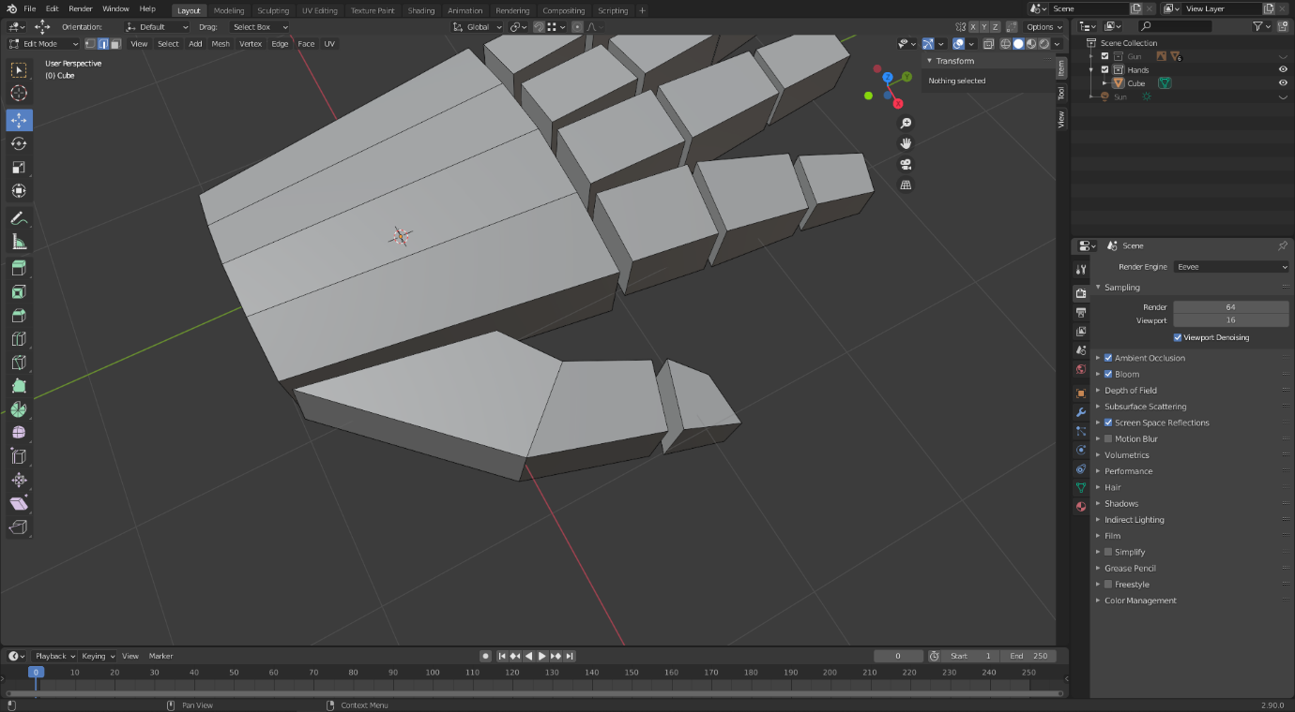

I then deleted every single face in between and combined all of the separate edges to join the fingers with the hand.

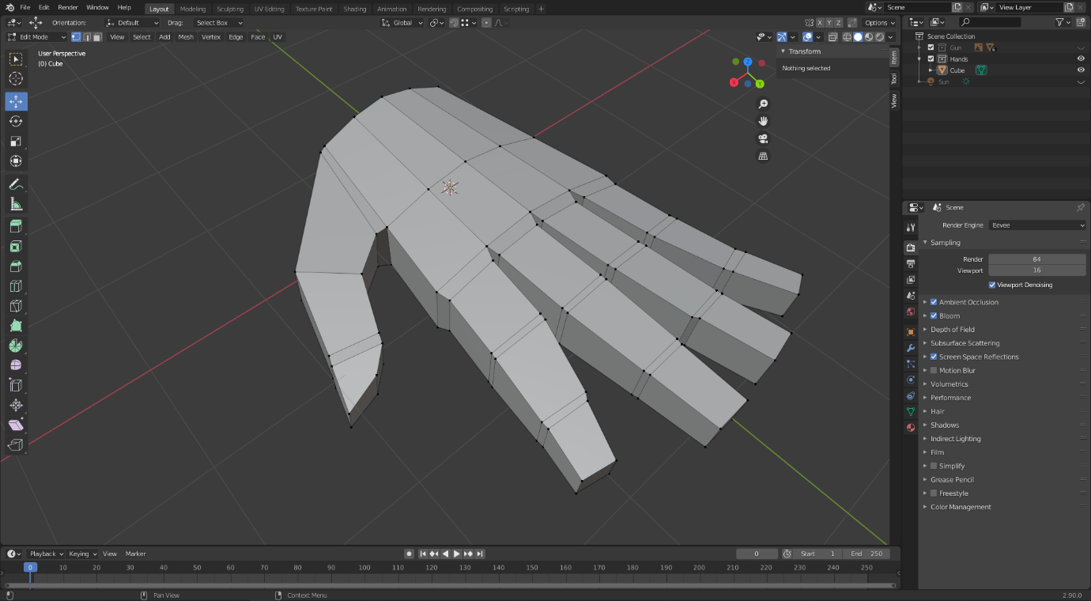

For the forearm and upper arm, I duplicated the other end of the hand before extruding out and scaling up as it goes. I also included a small bend in the middle to simulate the elbow.

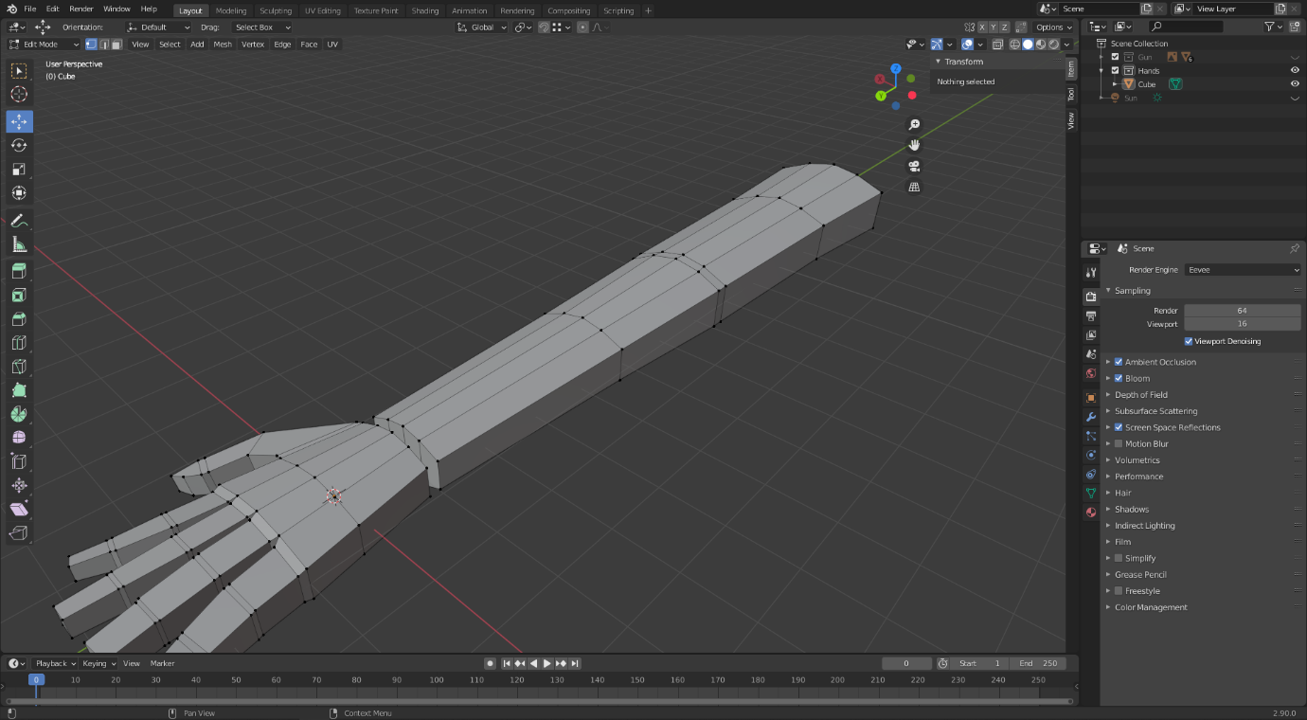

Once again, I deleted the end faces and joined the hand together with the rest of the arm.

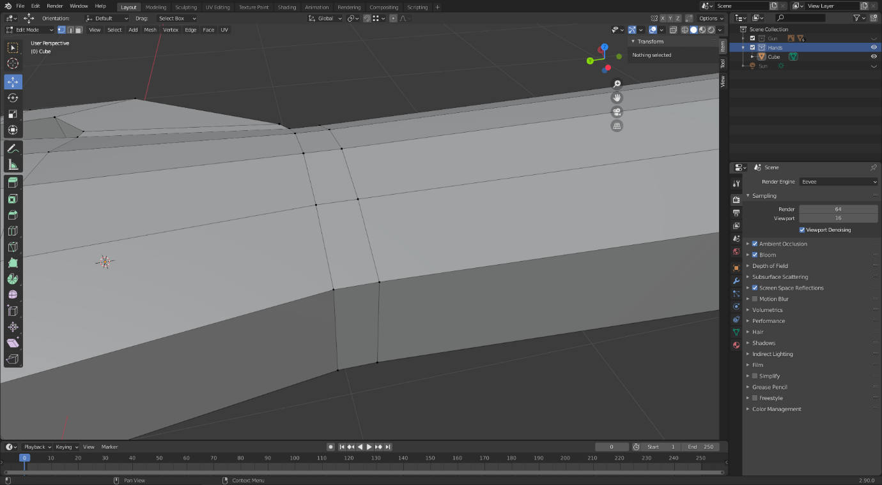

### Rigging

Next, I set about rigging the arm and the weapon. For the arm and hand, I created an origin armature which controls the overall position of the models, and then another one at the start of the hand where the shoulder joint would be. Then, I extruded outwards from this bone, creating one wherever a real bone would be. For the fingers, I went from the wrist and had four bones total for each finger, with three controlling the actual fingers themselves. Finally, I extruded upwards from the wrist and separated this bone to use as the hand controller.

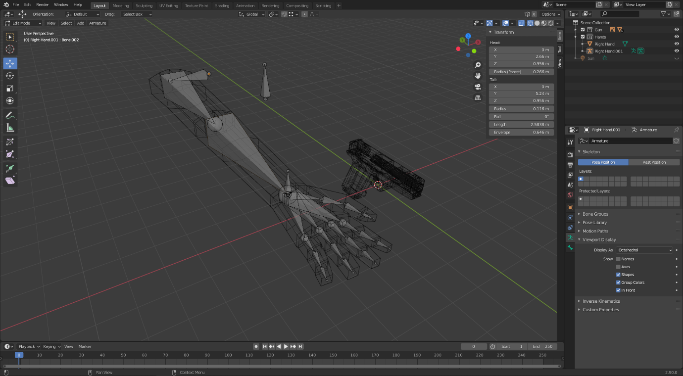

Next, I parented the first bone and the controller bone to the origin bone, and then created an IK constraint between the forearm and arm controller. With a chain length of two, this instantly made the entire hand follow the arm whenever the hand controller was moved.

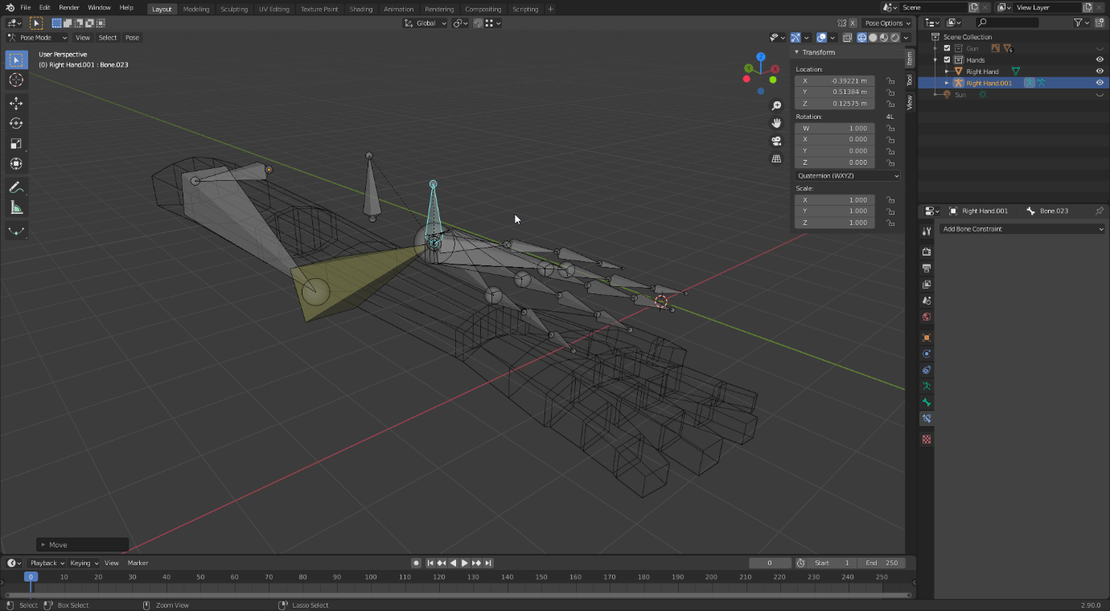

Next, I duplicated the armature and hand across, and set the x-scale to minus one in order to mirror it across. Finally, I used automatic weight painting to attach the armature to the arms.

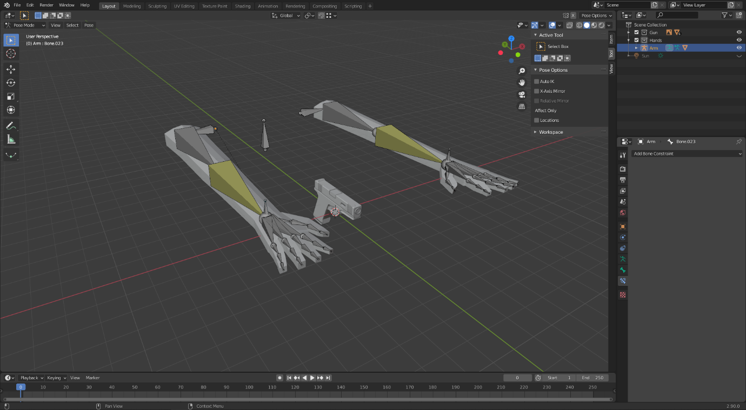

However, this did not work. The bones in the right fingers did not match up with the fingers being moved. This was due to the automatic weight painting failing.

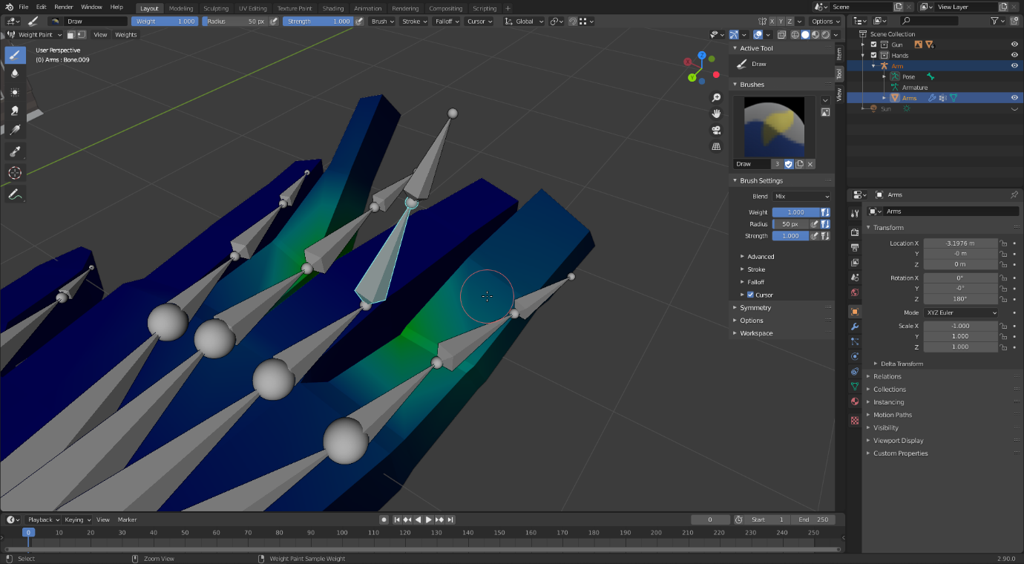

To fix this, I had to go through every single bone, set the weights that are in the incorrect places to zero, and add weights to the correct vertices. However, after getting through this process, the bones worked perfectly.

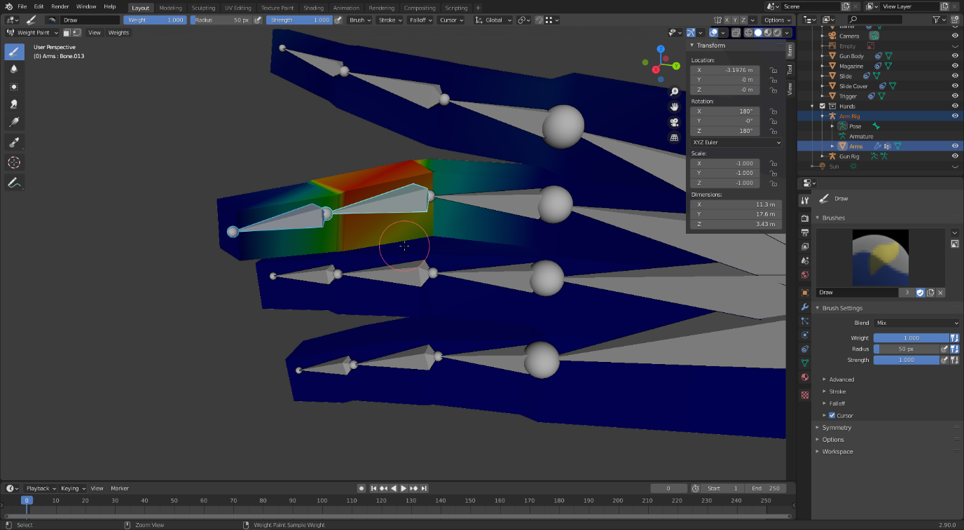

I also rigged the gun by creating a new armature and placing wherever there was a moving part. I then added an armature object constraint to those parts, with the target as their corresponding bone. This allowed me to animate the weapon without changing the model in any way.

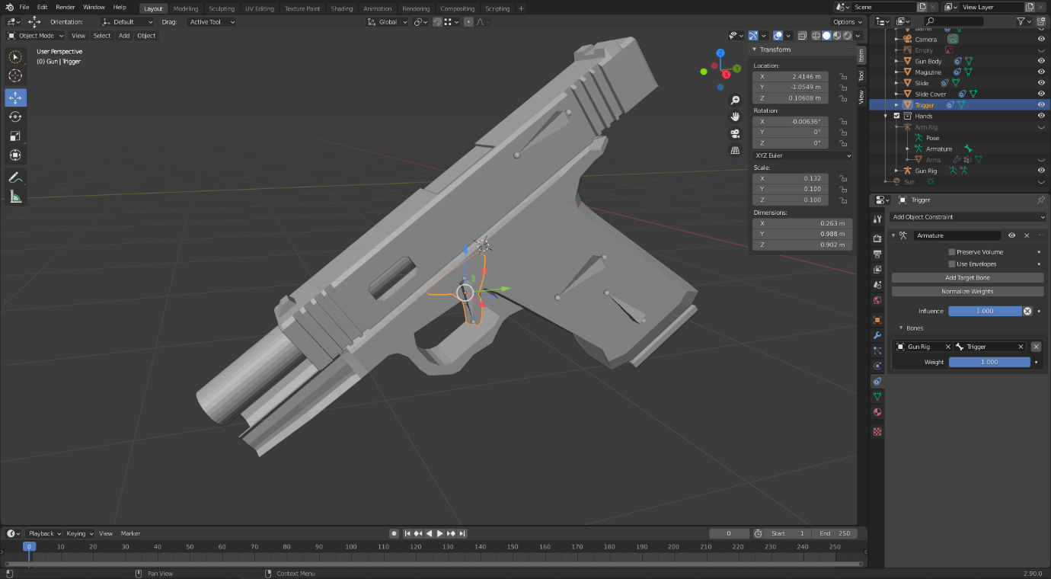

The last step in rigging was to fix the elbow positions. When I moved the arms, the elbows would bend due to the IK constraint, however they did not know how to behave like a real elbow, and so would bend in unnatural angles. To fix this, I extruded a new bone from the elbow, and added an IK constraint from it to the upper arm bone. I gave this a chain length of 1 so that it only affects that bone. Now, when the elbow isn’t bending correctly, I could move the new bone and the elbow would follow along.

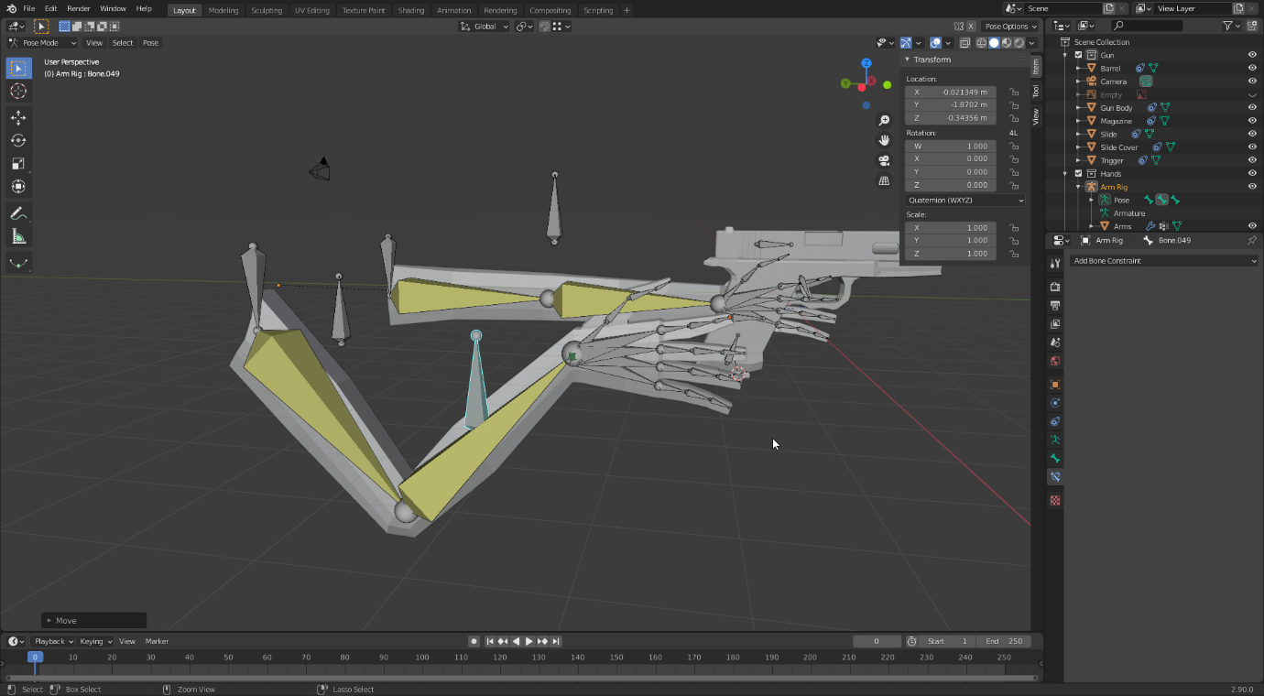

### Animation

With the rig finished, I moved onto the final step; creating the animation. As my inspiration was video game assets, I wanted to animate the different states the player would be in, such as equipping the weapon, aiming, shooting and reloading.

To begin, I set up the camera where the player’s view would be. I used this camera angle every time I made a change to the animation, as where it might look good from the program view it could look completely different from the point-of-view angle.

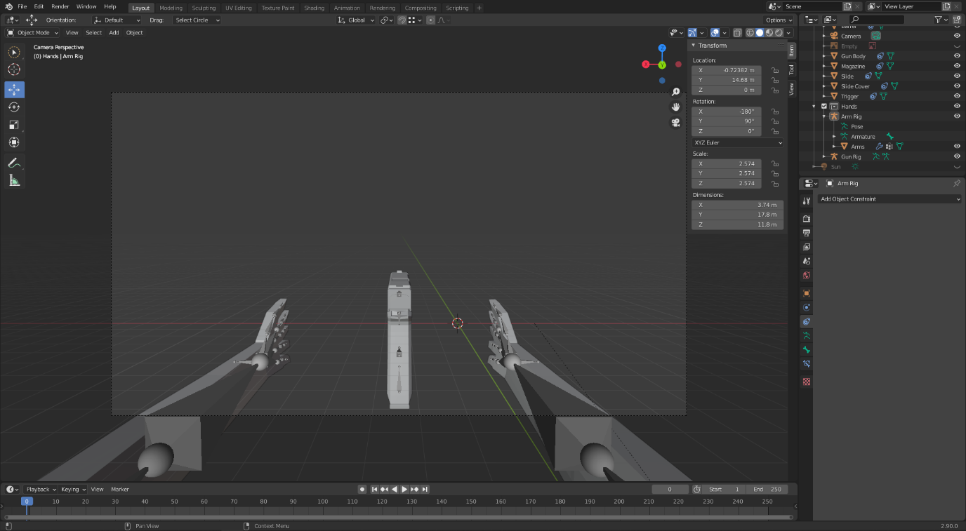

My first step in animating was to place the character’s hands on the weapon, as that will be the default pose that I will always return to. If these animations were being made for a real game, this would be extremely important as for every animation to blend well together the standard position would have to be the same. In this case, I did not have to worry about this, but I still tried to stick to it as much as I could. I manually positioned the armature using the pose tool.

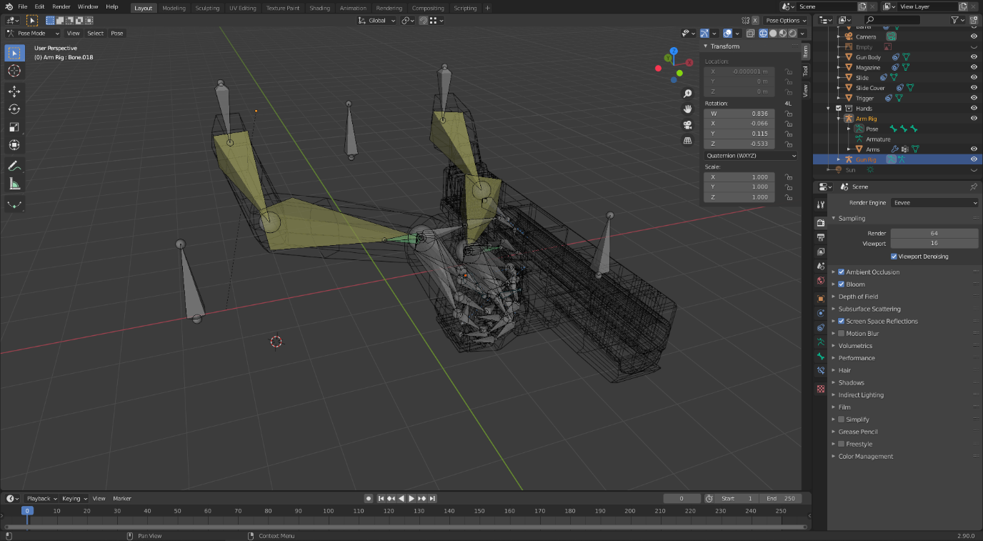

For the very first part of the animation, I keyframed the default position on the tenth frame, then took the weapon origin bone and moved as well as rotated it downwards on the first frame. With this, at the start of the animation the gun will be brought into view as though the ‘player’ just equipped it. Next, I went across the keyframes and slightly moved the weapon origin bone again in order to make it seem like the player is breathing and their arm is tired from holding the weapon up.

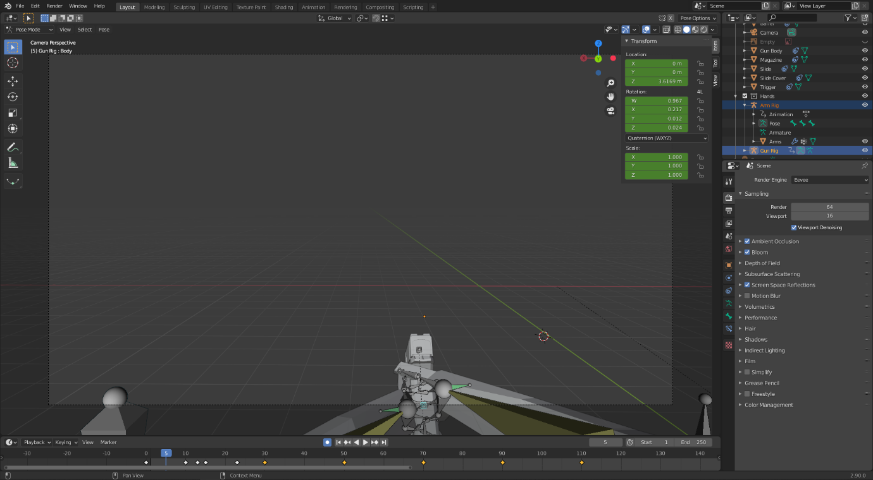

For every fast movement of the weapon, I went back a couple of frames and performed that movement again slightly more. This way for example, when the gun is brought up, it appears as though it bounces up a little bit before actually going to the normal position. This makes the movement appear tremendously more detailed and realistic compared to just smooth movements from one place to another, and I think this is one of the strong parts of my animation.

Next, I animated the shooting. To make it appear realistic, I only used five frames for the shooting, where the second frame is the end of the weapons recoil. This gives it a very snappy and powerful feeling. To animate the slide going backwards, I simply animated the slide bone going backwards and forwards before animating the weapon origin bone, and as the slide is parented to the origin it followed its movements. I then copied the keyframes four times to make it shoot as many times.

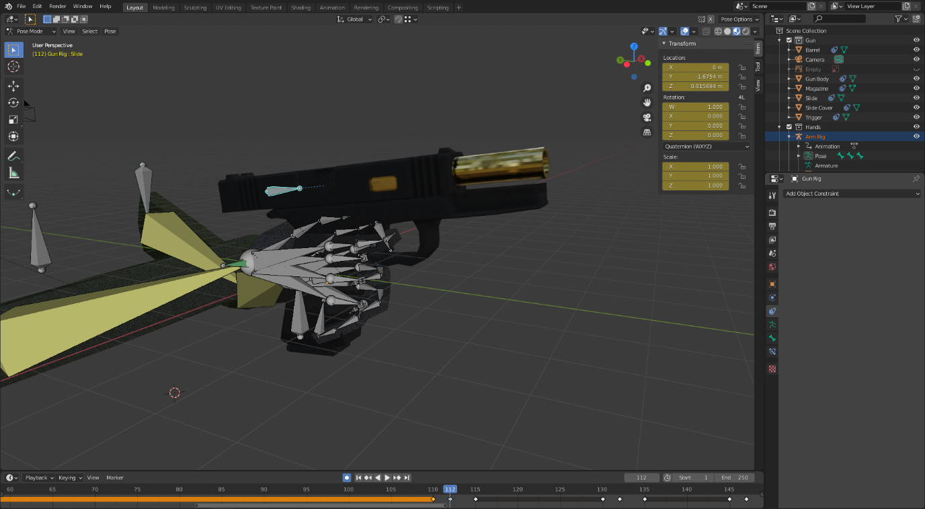

Next, I carefully animated the reloading part of the animation. This one was tricky as I was not experienced with animating hands, therefore, to keep it as natural as possible I attempted to use as little movements keyframes as possible and to keep them quick. In the end, I believe it would have looked better if I made it even quicker. Another point I made sure to follow was to keep the hand clear from the weapon in order to prevent it from clipping through and to make sure the viewer can see the weapon. An interesting thing to note is that whilst it appears like the magazine drops and a new one is put in, in reality there is only one magazine which moves back into the character’s hands.

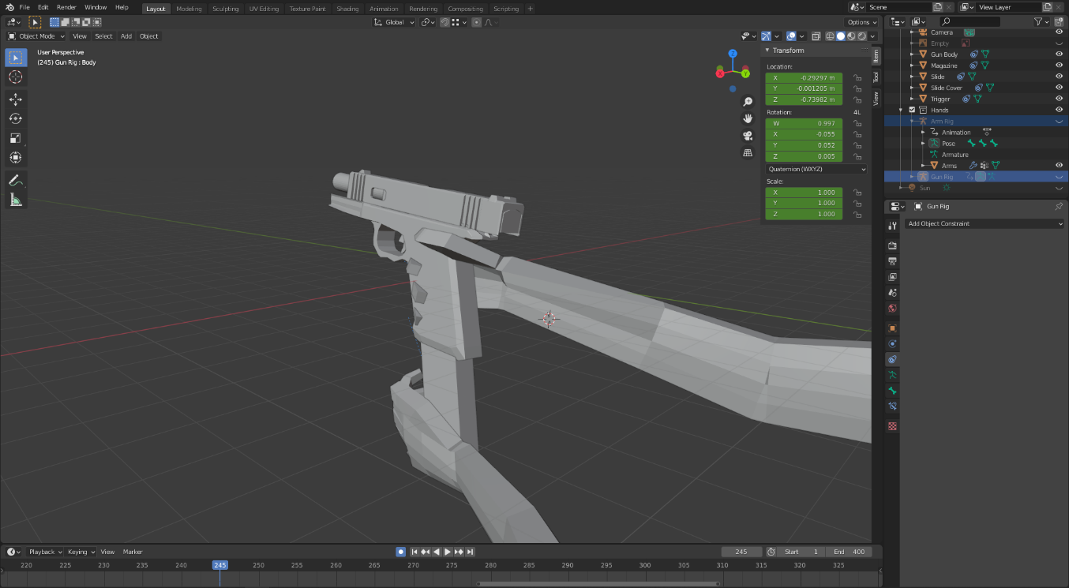

After that, I went back to before the shooting, and added an aiming down the sights animation. Because of the way I modelled the sights, this was easy to do as I could simply move the weapon origin bone until they lined up in the camera view.

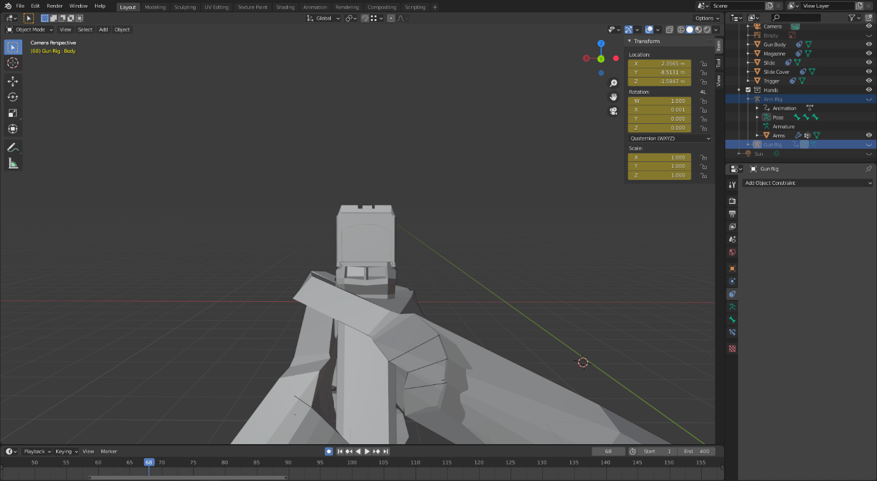

To show off the model more in the animation, I added a section where the character inspects the weapon. To get the best view, I put the weapon origin in the best position first, and then animated the sequence based on that position. This part helps give a better look at the model whereas before only the back and side were visible.

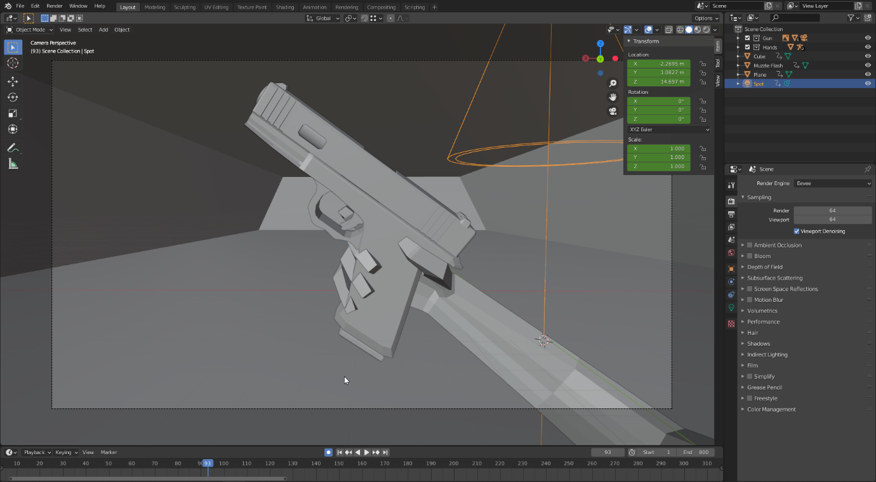

Finally, I copied the keyframes from the start of the animation but put them in backwards. This made the animation with the weapon going back out of view.

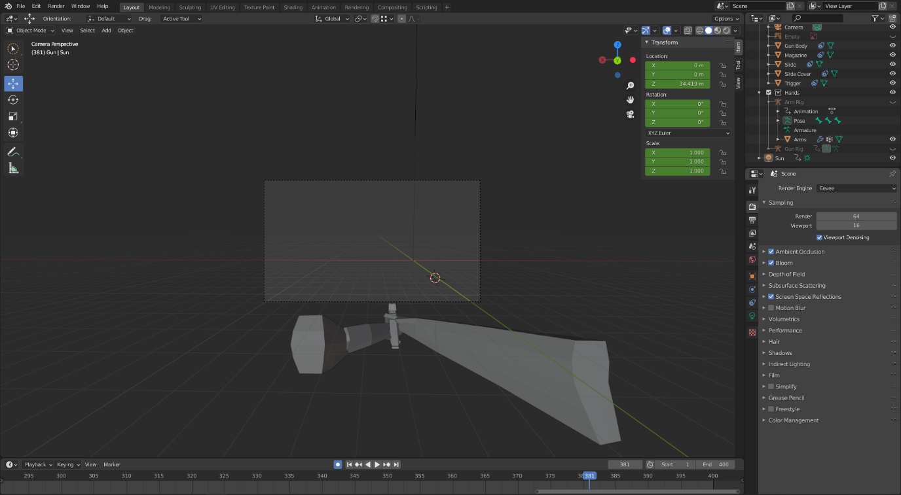

For the muzzle flash, I created a simple object out of a circle and experimented with random modifier values until it looked how I wanted. I keyframed the scale of this object to zero at all times except the exact frame when the weapon is fired. This once again gives a realistic look to the shooting, and makes the weapon feel more powerful and snappy. An interesting side effect of this is that occasionally, if the playback on the final render skips the exact frame the muzzle flash occurs, it will not be visible, which can also happen on real recordings due to how fast the muzzle flash occurs.

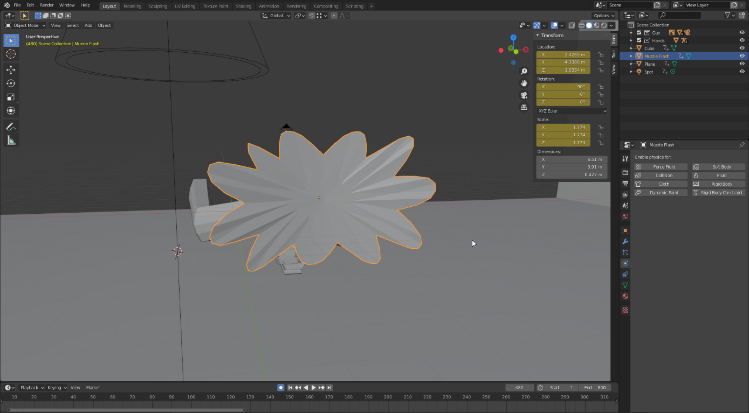

I created a simple material for this object, giving it some transparency, a light-yellow colour and some emission as well which makes it give off yellow light. Whilst it is a very simple way of making a muzzle flash and doesn’t look too realistic, I think it works quite well for its purpose and I was happy to be able to make it without any outside help or ideas.

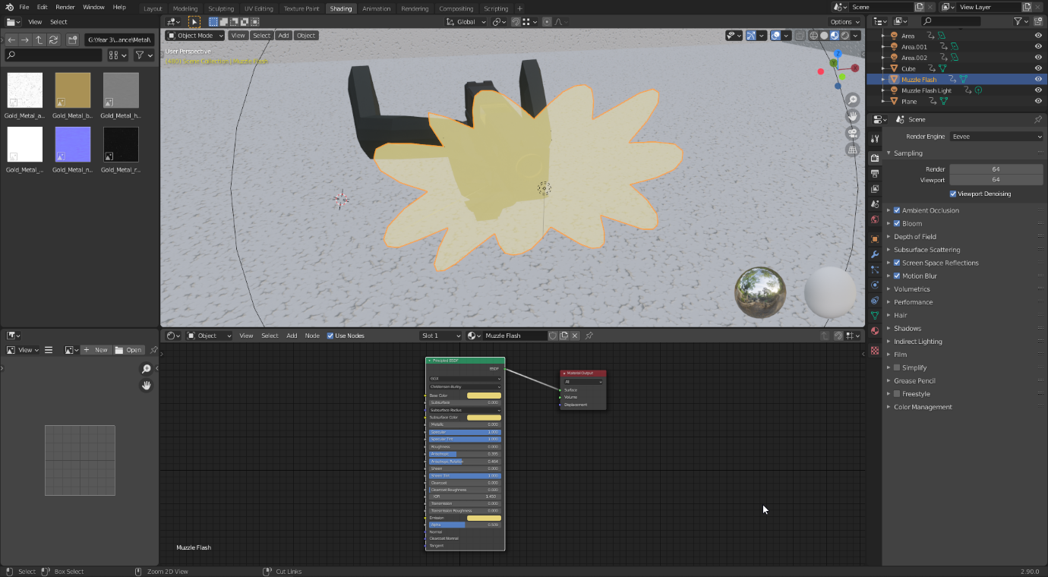

Finally, I added some lights to the scene, and as the last animation, I added an orange point light at the position of the muzzle flash, changing its power to zero at all times except the frame it is fired. This makes the shooting even more impactful than before, briefly lighting up the white surroundings with a contrasting orange light.

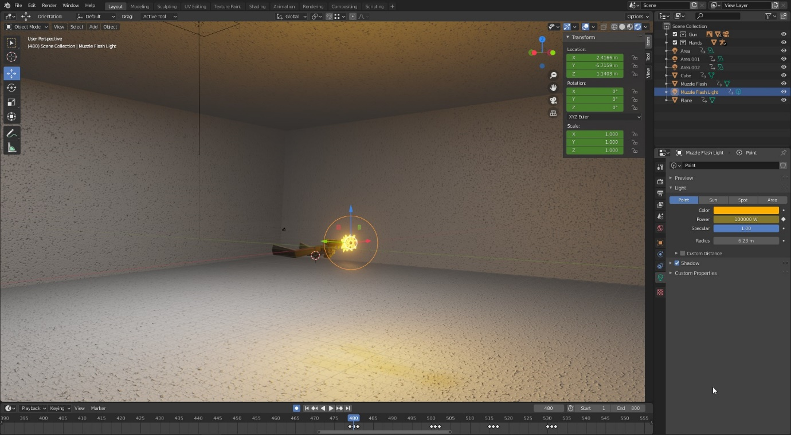

## Final Animation

Final Animation: <https://www.youtube.com/watch?v=aAzQiRVQOTg>

Screen View: <https://www.youtube.com/watch?v=YJropUCZxmw>

## Reflection

I am very pleased with my final animation. I believe the movements of the hands are realistic and smooth, and the way the weapon handles even more so. I am also happy with the weapon model, which I think looks detailed even though it doesn’t have a subdivision multiplier applied.

I wasn’t sure whether doing this type of project would be able to meet the criteria of the task, however I have generated a number of 3D models, materials, a basic environment, rigged a weapon and arms, and animated a number of actions with the model. Therefore, I am hopeful that the lack of any story and not much environment detail is evened out by the work I put into what I do have.

However, there are a number of improvements that I would like to have done. First of all, I would like to improve on my arm models, as this was my first-time modelling arms and I believe I could do much better a second time. I do believe the result was satisfactory, although it is extremely thin vertically.

Secondly, I would like to have animated bullets in the magazine, bullet casings falling out of the slide and a tracer effect when the weapon is fired. I think this would have made the animation even more realistic.

Finally, there was potential for more to be done with the animation, such as moving around a scene, and even fighting some kind of enemies as a sort of ‘fake gameplay’. This would have brought the animation past the point of an ‘asset demonstration’ and more towards an actual short action film.

# References

# External Assets Used

Sounds

Gunshots and Bullet Shells Falling – Mike Koenig, Marcel from soundbible.com

<http://soundbible.com/2120-9mm-Gunshot.html>

<http://soundbible.com/2072-Shell-Falling.html>

Handgun Cocking, Magazine Loading SFX – Audio Library – Free Sounds Effects from YouTube

<https://www.youtube.com/watch?v=xJlPsvCU2HY>

<https://www.youtube.com/watch?v=ZvCEvbNXzRw>

Cloth Foley – Yau Audio from YouTube

<https://www.youtube.com/watch?v=xMlizZwH9Bg>